THOMAS
HASSALL
ANGLICAN
COLLEGE

Year 11 Industrial Technology Portfolio Workbook
Statement of Intent section

Student Name: ___________________________

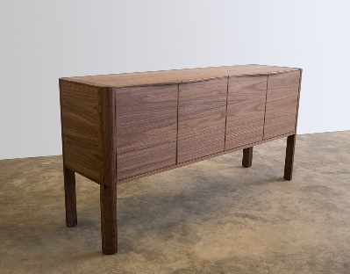
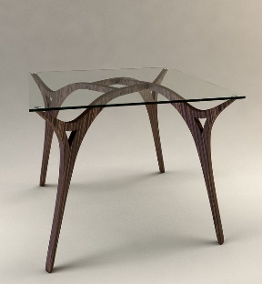
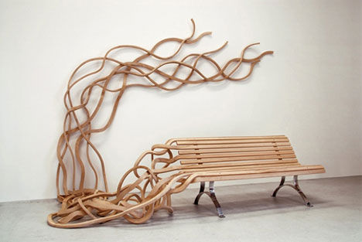
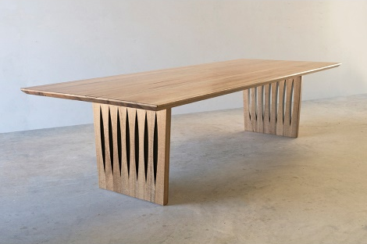
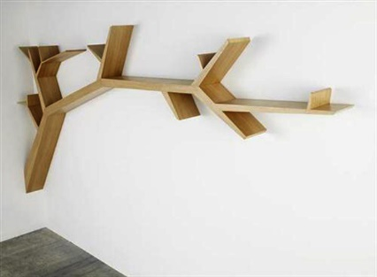
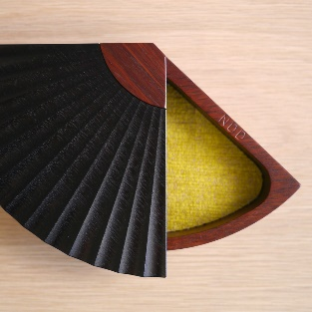

Title page example…

The title page should be a colourful introduction with a well presented heading and photographs of your finished project. You can put your student number on this page and the course title, however do not put your name on any of the pages.

Example…

Industrial Technology – Timber

HSC Major Work 2016

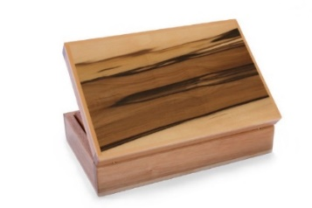
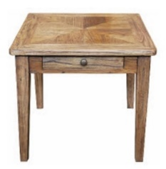
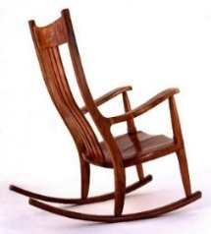
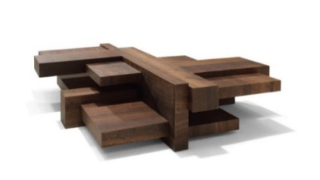
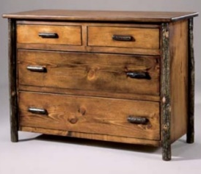
Figure 1: these picture represent what you finished project could look like.

Student number – 3578909

Design your Title page…

Contents
Title page example… 2
Design your Title page… 3
Design 5
Statement of Intent 5
What have you decided to design? 5
What will this design consist of? 5
What will you call your project? Why? 6
What applications will your project be used for? 6
Where will your project be used? 6
Motivation and purpose for the project 7
Motivation 7
Purpose 7
Parameters of the design 8
Parameters 8
Possibilities of the project 8
Possibilities 8
Interesting materials or resources or features of your major 8
Conclusion – ongoing evaluation 9

Design

Statement of Intent

What have you decided to design?

________________________________________________________________________________________________________________________________________________________________________________________________________________________________________________________________________________________________________________________________________________________________________________________________________________________________________________________________________________________________________________________________________________________________________________

Example: I have decided to design a coffee table for my Major Project…

What will this design consist of?

________________________________________________________________________________________________________________________________________________________________________________________________________________________________________________________________________________________________________________________________________________________________________________________________________________________________________________________________________________________________________________________________________________________________________________

Example: it will have two drawers…

What will you call your project? Why?

________________________________________________________________________________________________________________________________________________________________________________________________________________________________

Example: I will call my project ‘the roman coffee table’

What applications will your project be used for?

________________________________________________________________________________________________________________________________________________________________________________________________________________________________________________________________________________________________________________________________________________________________________________________________________

Example: it will be used for putting coffee or magazines on/storage place

Where will your project be used?

________________________________________________________________________________________________________________________________________________________________________________________________________________________________________________________________________________________________________________________________________________________________________________________________________

Example: it will be used in the living room or TV room or…

Motivation and purpose for the project

Motivation

________________________________________________________________________________________________________________________________________________________________________________________________________________________________________________________________________________________________________________________________________________________________________________________________________

Example: the project is being built for the empty space in my living room…

Purpose

________________________________________________________________________________________________________________________________________________________________________________________________________________________________________________________________________________________________________________________________________________________________________________________________________

Example: the coffee table could be used for resting your legs after a hard day’s work, so durability is important…

Parameters of the design

Parameters

________________________________________________________________________________________________________________________________________________________________________________________________________________________________________________________________________________________________________________________________________________________________________________________________________

Example: look appealing in the environment it will live in…keep to the budget I have set…

Possibilities of the project

Possibilities

________________________________________________________________________________________________________________________________________________________________________________________________________________________________________________________________________________________________________________________________________________________________________________________________________

Example: using spotted gum for my table for an old fashion look…an aluminum frame for the legs…

Interesting materials or resources or features of your major

________________________________________________________________________________________________________________________________________________________________________________________________________________________________________________________________________________________________________________________________________________________________________________________________________

Example: using two timber types for a contrasting look to my major…

Conclusion – ongoing evaluation

________________________________________________________________________________________________________________________________________________________________________________________________________________________________________________________________________________________________________________________________________________________________________________________________________

Example: in conclusion to my statement of intent I intend to create an appealing coffee table…

