PORTFOLIO:
jhowe
2015-05-18 23:28:57
--------------------------------------------
Good title page well done.

TIMBER JOINT FRAME

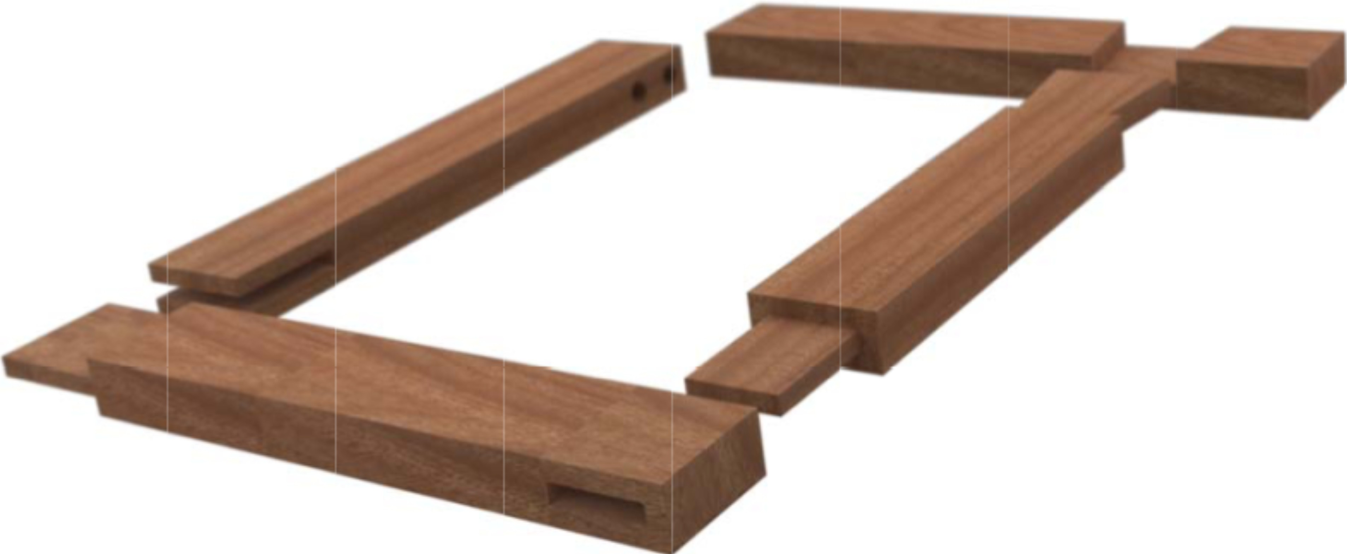

TABLE OF CONTENTS
jhowe
2015-05-18 23:29:16
--------------------------------------------
Excellent contents page
Statement of intent 1
This page is for a descriptive presentation of what this project is and why this design project is being produce. It shows the outcome for this project and a brief description of the design project.
Research 2
This page includes the advantages and disadvantages of each joint type. The joints includes the Dovetail halving joint, mortise and tenon joint, dowel joint and bridle joint. This page will also include examples of uses of each joint type and images of the joints.
Research Dovetail 2
Research Mortise and tenon joint 3
Research Dowel joint 4
Research Bridle joint 5
Finance plan 6
This page will show all the materials used, the dimensions taken, the cost for all the material and the overall cost.

Appropriate industrial processes and equipment 7 - 14
This page will demonstrate a detailed step by step plan of the joint frame. This will also consist of the tools and work practices for the joint frame.

Safe work processes and WHS 15 - 16
This page consists of documented evidence of secure work practices and workplace health and safety for the project. This page will also include OnGuard certificates for approval of working in the workshop, PPE and evidence of a safe use of tools in the workshop.

Evidence of computer and applications 17
Computer applications used within the portfolio such as solid works.

Bibliography 18
Includes all references made throughout the portfolio.

STATEMENT OF INTENT

The joint project is a sophisticated and admirable piece of work. It is made from the finest Tasmanian oak which is then precisely cut and carved into making the joints. Each joint consists of the dovetail joint, mortise and tenon joint, dowel joint and bridle joint. The timber frame is very straightforward but requires many techniques to construct the timber frame. As a result we then develop the skills to to produce quality hand cut joinery.

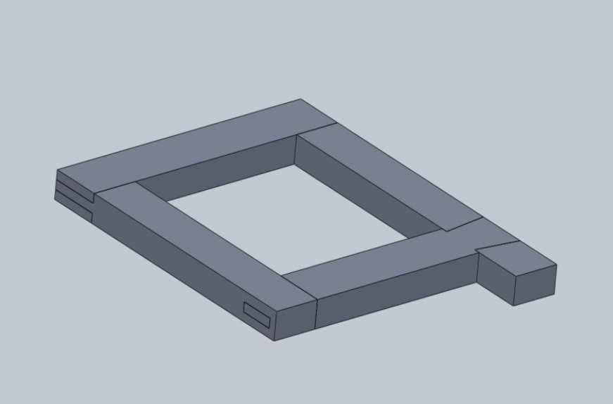Each 250mm wood is individually cut and sculptured into each of the joints. Each piece contains different types of joints which is then precisely intersected between one another, therefore creates the timber frame. Each joint requires different techniques and hand tools such as using the chisel and knowing how to carve with it. This will allow the students to develop skills very fast and it is great for students who want to complete Industrial Technology in stage 6.

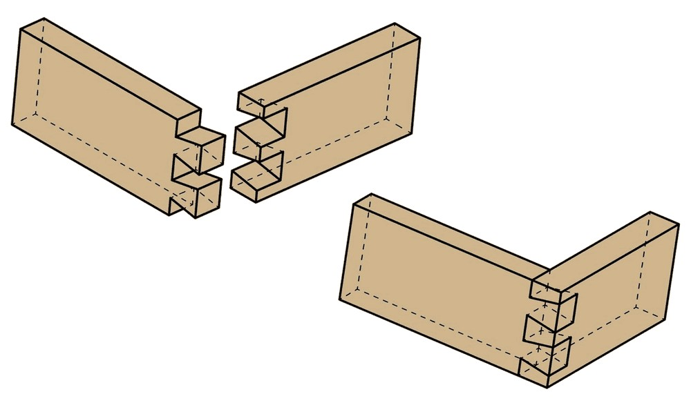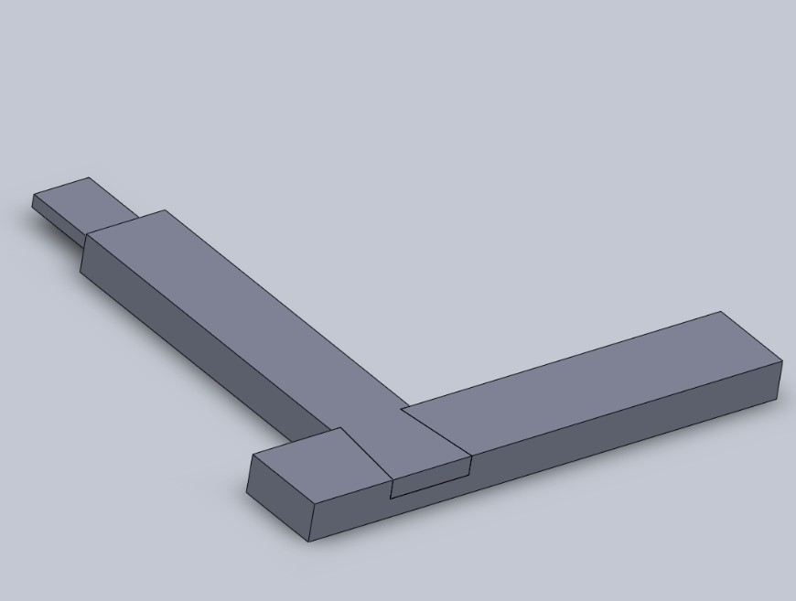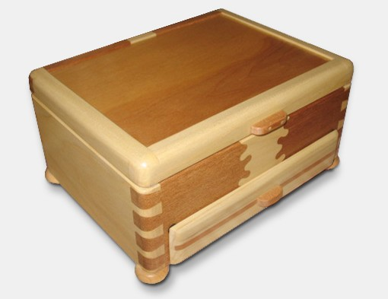
jhowe
2015-05-18 23:31:44
--------------------------------------------
Very similar to something i found in google be very careful not to plagarise.

Dovetail joint

A dovetail joint is a very common woodworking joint which helps bond two corners together. It is a very strong joint because of how the 'tail' and 'pin' are shaped. For this reason it is very difficult to pull apart and virtually impossible when glued together.

The dovetail joint is suitable for most box constructions such as draws, jewellery boxes, cabinets and other furniture that require strength. This well constructed joint is usually made up of a three pin setup but can be configured to make less or more pins depending on the strength and aesthetics you require.

When this joint is done correctly, it will look very pleasing but this requires many skills. You need exact measurements and straight cuts to make this joint very impressive. It is a very difficult task that needs practice and skills. Depending on the amount of pins and tails, this joint is a time consuming project because it requires the perfect dimensions in order for the pins and tails to fit.

The dovetail joint is a very popular joint used in woodworking furniture. A jewellery box is a very common box construction that uses the joint. The dovetail joint helps fit the sides of the box for a very secure and strong hold. Not only is it a durable joint, the joint itself looks very admirable and unique.

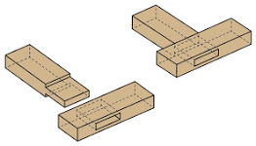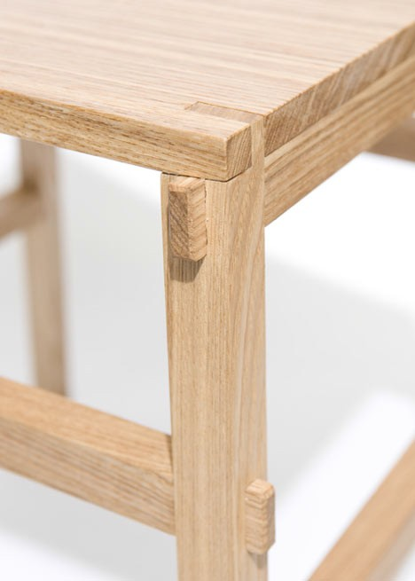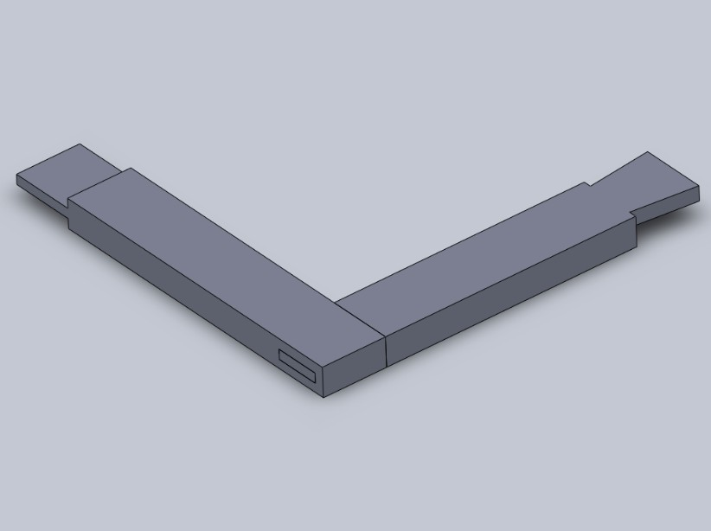Mortise and Tenon joint
jhowe
2015-05-18 23:33:42
--------------------------------------------
Excellent well set out.

The mortise and tenon joint is a common joint used for many projects that have a frame construction or requires strength. The joint is fairly difficult and does require some skills but it is aesthetically pleasing. The mortise and tenon joint is one of the strongest joint that can hold table and chair legs together. The mortise and tenon joint consists of a tongue that is secured into a slot and glue together. The tongue must fit tightly into the slot otherwise it will twist and break it off.

The mortise and tenon joint is a very sophisticated but unique joint. It is a very neat and strong joint as the tongue hides inside of the slot which therefore leaves no mark of work. The joint is extremely strong that it is exceptionally difficult to pull out and break, this is for the reason why the joint sits compacted inside of the slot and is usually glued.

An advantage in using the mortise and tenon joint is that it cannot wobble. This is useful when using the joint as many other joint has the potential to wobble and fall out of place.

The disadvantages of a mortise and tenon joint is that it can be fairly difficult to mark out and cut. The joint requires precise measurements in order for the tongue to perfectly fit in the slot. This then takes time and effort into making the joint. If the measurements are off, it can create poor resistance to the tenon, especially when fitted badly.

The mortise and tenon joint is a perfect joint used for table and chair legs. The joint will create a strong and stable balance when the table or chair is used. Not only is it strong but the joint is very appealing and unique as the actual joint is hidden inside the wood.

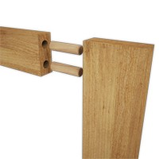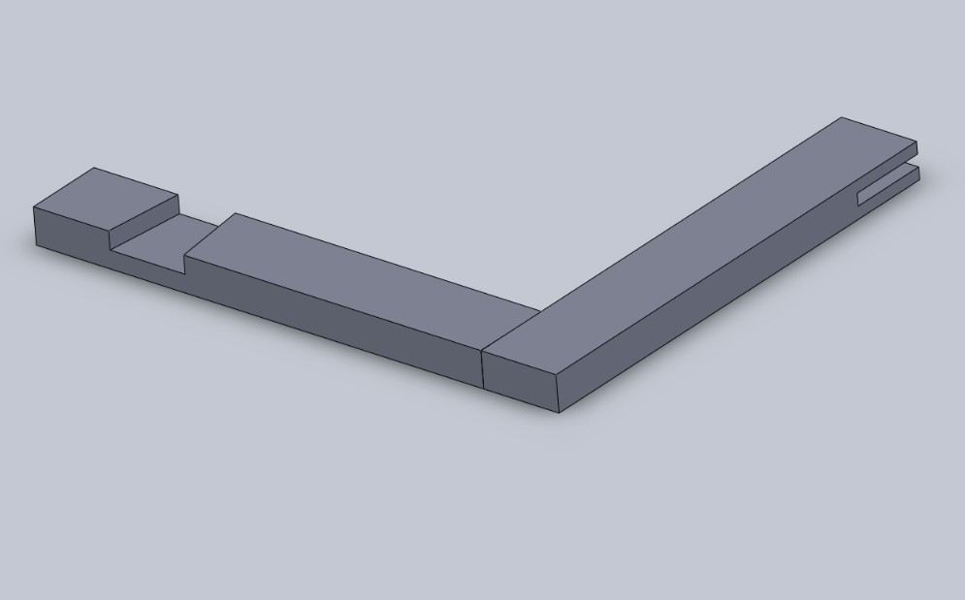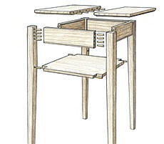Dowel joint
jhowe
2015-05-18 23:33:55
--------------------------------------------
Well done excellent work

The dowel joint is a common joint used for many things made in the woodworking industry. This type of joint consists of a small piece of dowel secured on the wood piece. The dowel is then inserted into the hole of the joining wood and glued in placed. It is a very strong joint that looks very neat and is used in many woodwork projects.

In order to accomplish the dowel joint, you must accurately drill holes into the wood which should be 2mm or more and securely place the dowels into them. The dowels are commonly 10mm and 13mm in diameter, although there are many types of dowel sizes that fit each project differently.

The advantages of using the dowel joint is that it is very easy to make and very straightforward. The joint has a very strong hold to it as the dowels usually have grooves on them to stop it from slipping out.

The disadvantages of using the joint is that it takes accuracy to measure the dowels or else the dowels won't fit. This is a very common mistake as many students will have to restart and make new holes. If not enough time is taken in to measure the holes out it will take several pieces of wood to perfectly fit the dowels in the hole.

There are tools such as the "dowel centre" which helps improve the accurate measuring on both piece of joining wood. This will prevent many mistakes used in making the dowel joint.

This joint is a very good joint used for furnitures such as tables, chairs and cupboards. Here shown in the picture is a very simple table or night stand that uses the dowel joint for its strength. Another reason why they sue this joint is because of the joint hidden inside and cannot be seen.

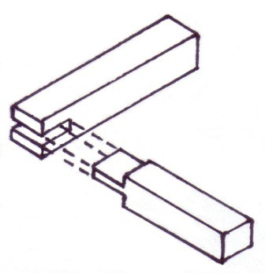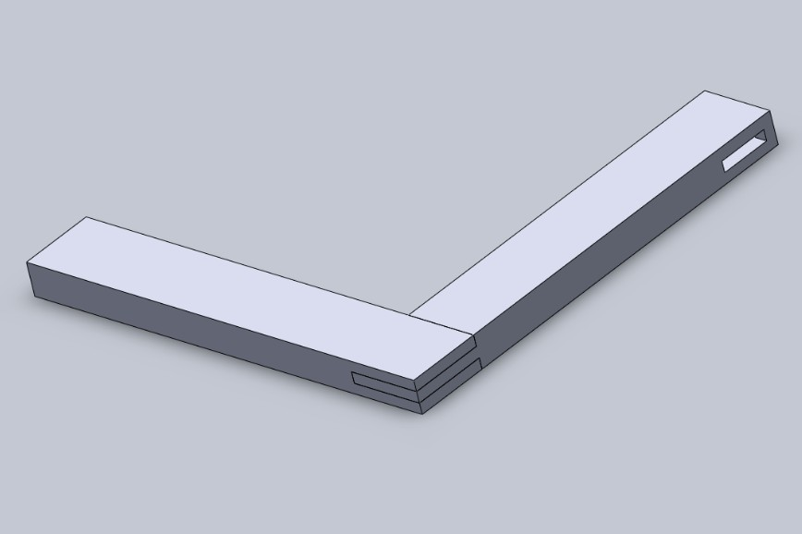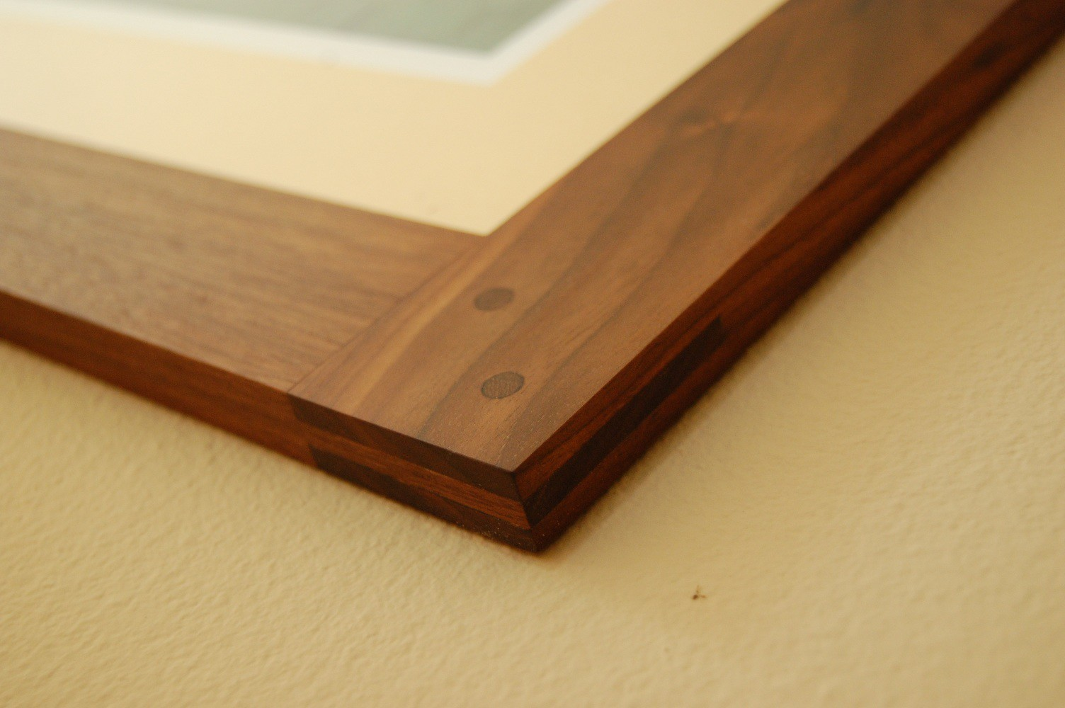Bridle Joint
jhowe
2015-05-18 23:34:26
--------------------------------------------
Try and keep all heading and subheading consistent throughout the whole document.
jhowe
2015-05-18 23:34:35
--------------------------------------------
Well done.
jhowe
2015-05-18 23:35:53
--------------------------------------------
In the future evaluate all this text that has been written just to have a summary of all information.

A bridle joint is a very useful and popular woodworking joint, it is also similar to the mortise and tenon joint but the difference is in size of the mortise and tenon. The joint is used for many woodworking designs which is why it is often chosen.

The advantages of using the bridle joint is that it is very useful for light woodwork such as a picture frame. The joint is very use full for many small projects that require little skills as their is no holes or intricate work.

The disadvantages of using the bridle joint is that it is not a joint used for strength, it can only hold light weight projects. The bridle joint also requires precise measurements and cutting otherwise the joints will not fit and may snap off. The bridle joint is not a very appealing joint as the top of the joint shows the end grain.

The bridle joint is used for many woodworking projects such as a picture frame. The joint is very popular in this industry as it is easy to make and is not time consuming. Once the joint is finished, you can chose to glue the joints together as it will hold together better.

Finance plan

The Tasmania oak is a perfect material used for many work projects and is ideal for all school projects. It has a nice colour to it and is very inexpensive. Tasmanian oak can be bought in many building warehouses such as Bunnings warehouse, Mitre 10 and masters. Each store sells Tasmanian oak at different prices. On average the 42x19 lm piece of wood is only $3.95 and for our wood project each 250mm wood would be
$0.9875. Since the wood is very inexpensive many people buy Luke prefer to but this dark Tasmanian oak.

ITEM | TIMBER SIZE (LM) | $ COST | $COST PER 250MM
Dark Tasmanian oak | 42x19 | $3.95 | $0.9875

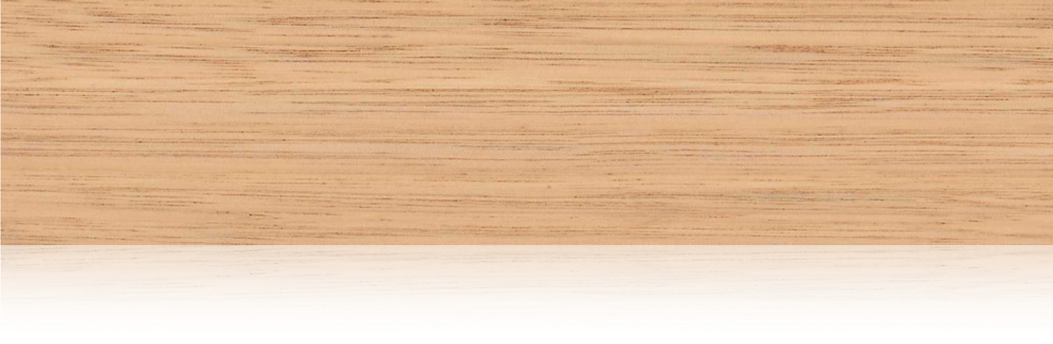

6

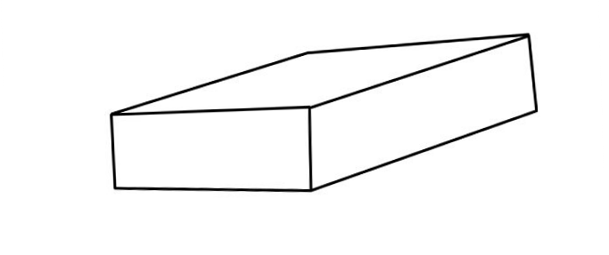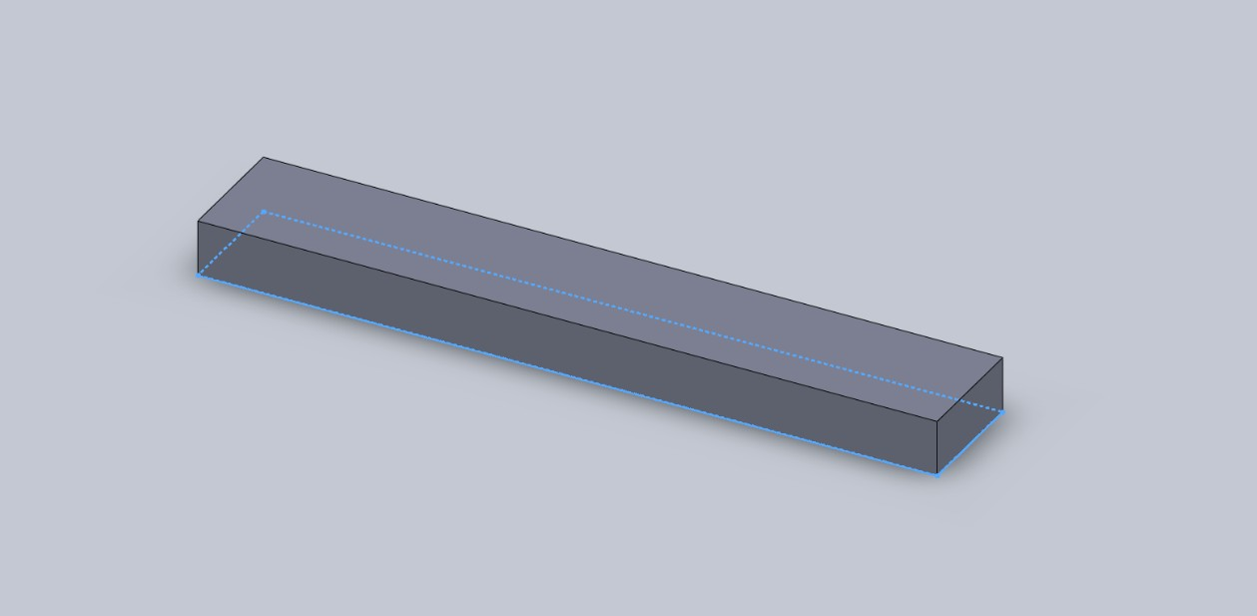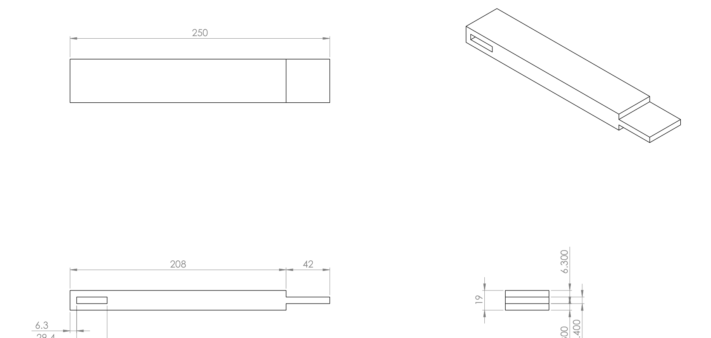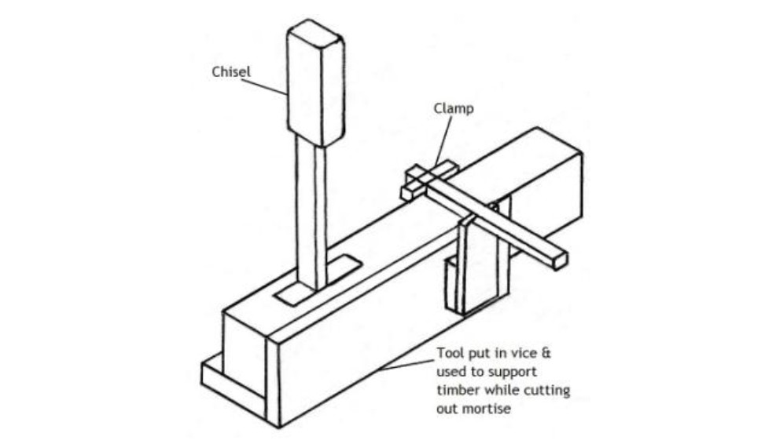Appropriate Industrial Processes and Equipment (Mortise and Bridle)
jhowe
2015-05-18 23:36:41
--------------------------------------------
Excellent work well done.
jhowe
2015-05-18 23:37:01
--------------------------------------------
Next time have pictures of you working and using these tools.

Step one:
Take the Tasmanian oak and cut it into four equal parts of 250mm pieces. Tools/Justification:
Ruler (To measure in exact) Pencil (For marking and drawing) Try square (For straight lines)

Step two:
Mark out the dimensions for the bridle and mortise joint with a pencil, ruler and try square for perfect lines. The picture shows the dimensions used for both joint Tools/justification:
Ruler (to measure in exact) Pencil (For marking and drawing) Try square (For straight lines)

Step three:
Firstly cut the bridle joint with a tenon saw. You must place the piece upright in the vice so you have more control of the saw. As show in the diagram as the dotted line, cut outside the line so the cut has enough room for mishaps. Tools/justification
Tenon saw (Used to cut timber)
The vice (For holding timber in place with strength)

Step four:
Lastly cut the mortise joint. In order to cut the mortise you will need to clamp the piece into the vice. Then proceed by using a chisel and a mallet too gently chip away the wood. Tools/justification
The vice (to securely hold the wood piece in place)
Chisel (To effectively chip the wood out) Mallet (A hammer used to work with a
7 chisel for tapping)

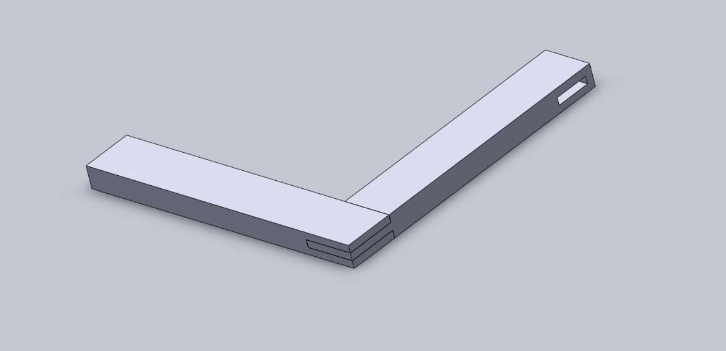Step four:
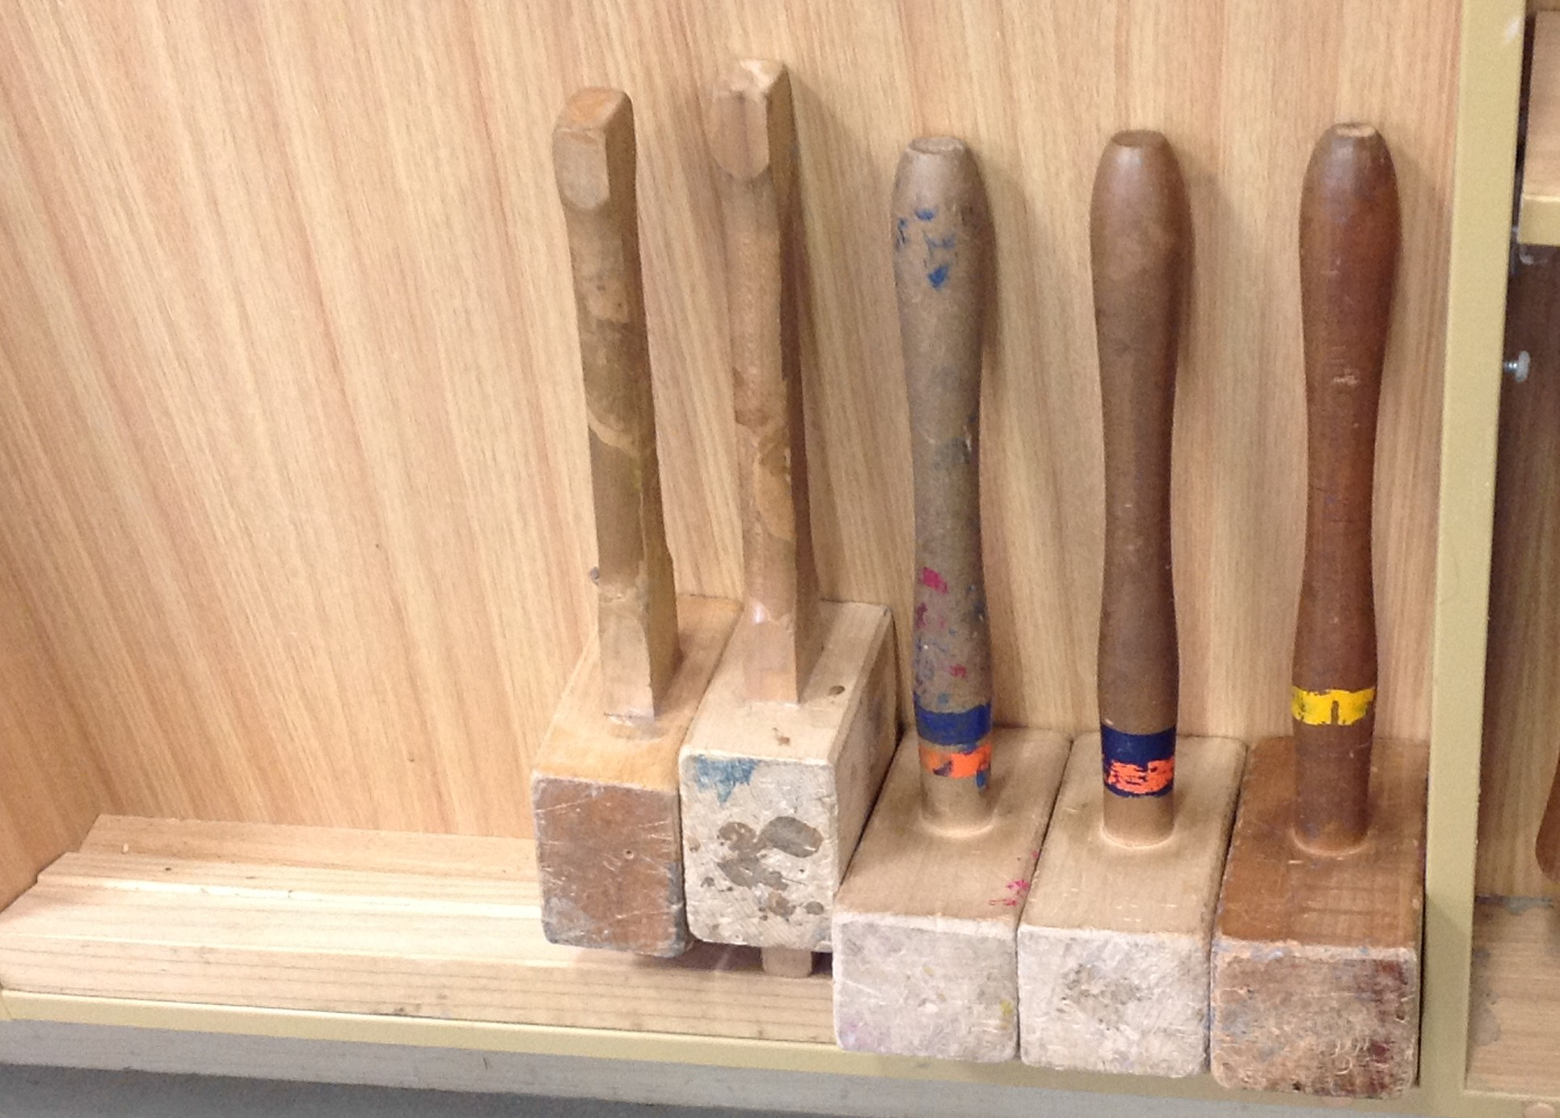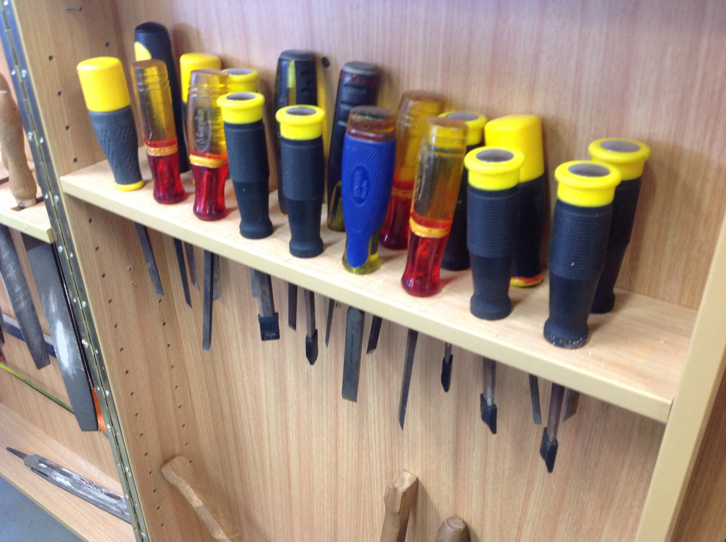The last process of completing this joint is to make sure the cuts are straight and that the joint fits into one another. After dry assemble and glue with adhesives.

Appropriate Industrial Processes and Equipment (Bridle and Dowel)

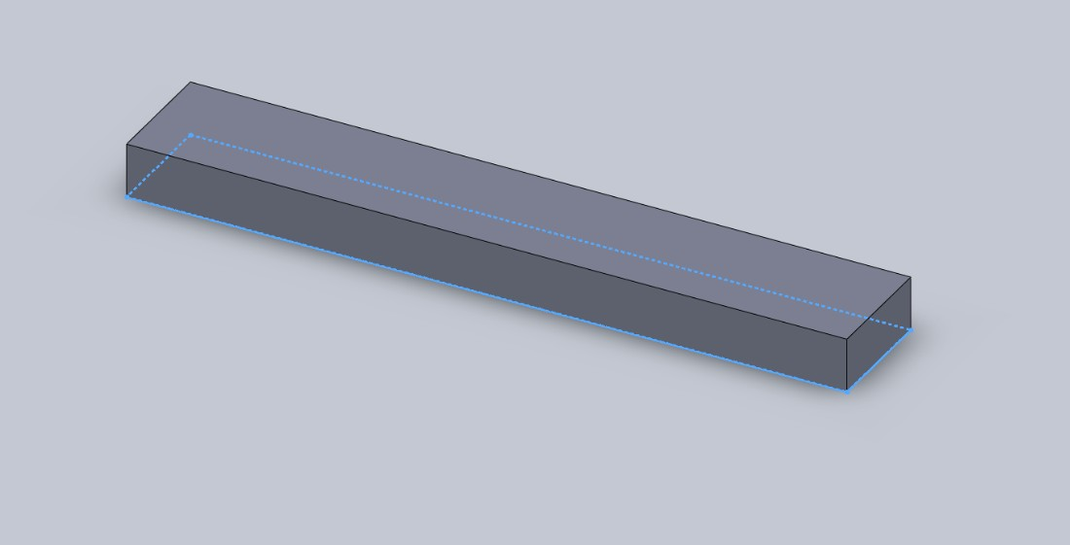Step one:
Take the Tasmanian oak and cut it into four equal parts of 250mm pieces. Tools/Justification:
Ruler (To measure in exact) Pencil (For marking and drawing) Try square (For straight lines)

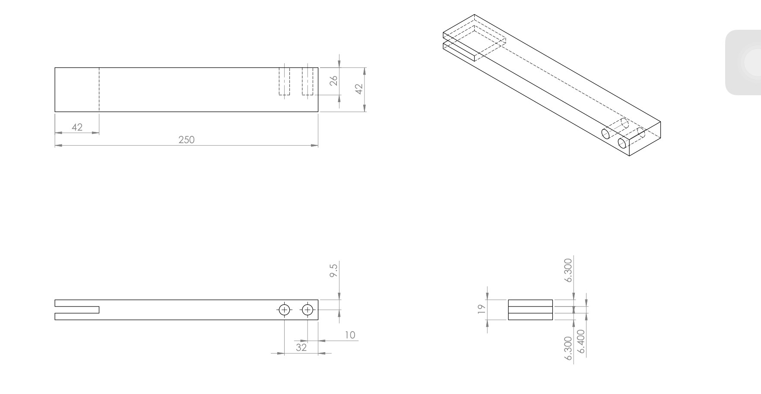Step two:
Mark out the dimensions for the bridle and dowel joint with a pencil, ruler and try square for perfect lines. The picture shows the dimensions used for both joint Tools/justification:
Ruler (to measure in exact) Pencil (For marking and drawing) Try square (For straight lines)

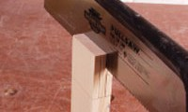Step three:
Firstly start with the wood piece clamped inside the vice with the dimensions for the bridle joint on top. Get out your tenon saw an cut out the the middle section as shown in the picture.
Tools/justification
The vice (to securely hold the wood piece in place)
Tenon saw (Used to cut timber)

Appropriate Industrial Processes and Equipment (Bridle and Dowel continued)

Step four:
After the two sides are cut, take out your chisel and mallet and start to slowly chip away the middle section. Tools/justification
Chisel (To effectively chip the wood out) Mallet (A hammer used to work with a chisel for tapping)

Step five:
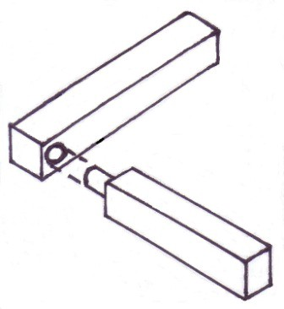We then finish of this joint by completing the dowel joint on the other side of the piece. We make the 10mm holes by using the dowelling machine. We first place the wood piece into the machine by adjusting the measurements to fit your dimensions. Make sure you have your safety glasses on for protection. Any hair or tie should be tied up or tuck away. Then proceed into turning the machine on and slowly pulling the handle for the drill to go in. You must go slow in order for a clean cut. After this is done take some pva glue and drip some into the two holes. Quickly grab the two wooden dowels and place them into the holes.
Tools/justification
Dowelling machine (A special machine used to make the perfect holes for dowelling)
PVA glue (A perfect gluing agent used to bind the dowel within the holes)

Step five:
The last process of completing this joint is to make sure the cuts are straight and that the joint fits into one another. After dry assemble and glue with adhesives.

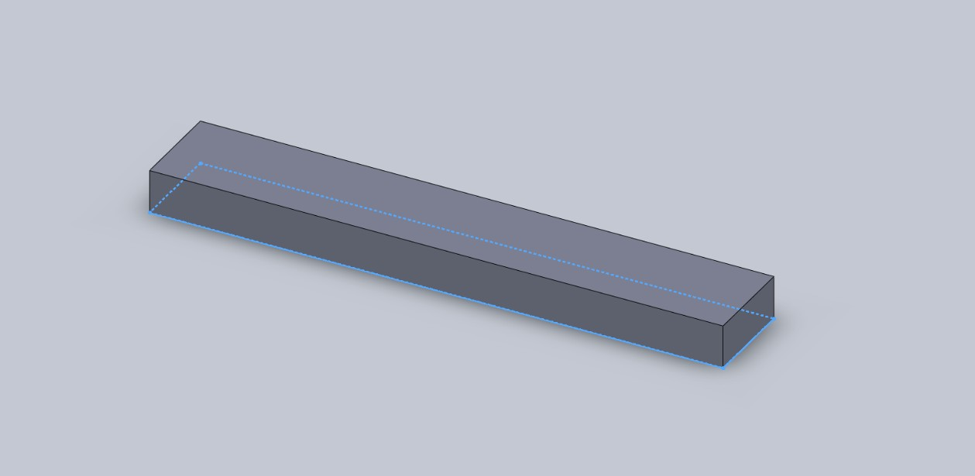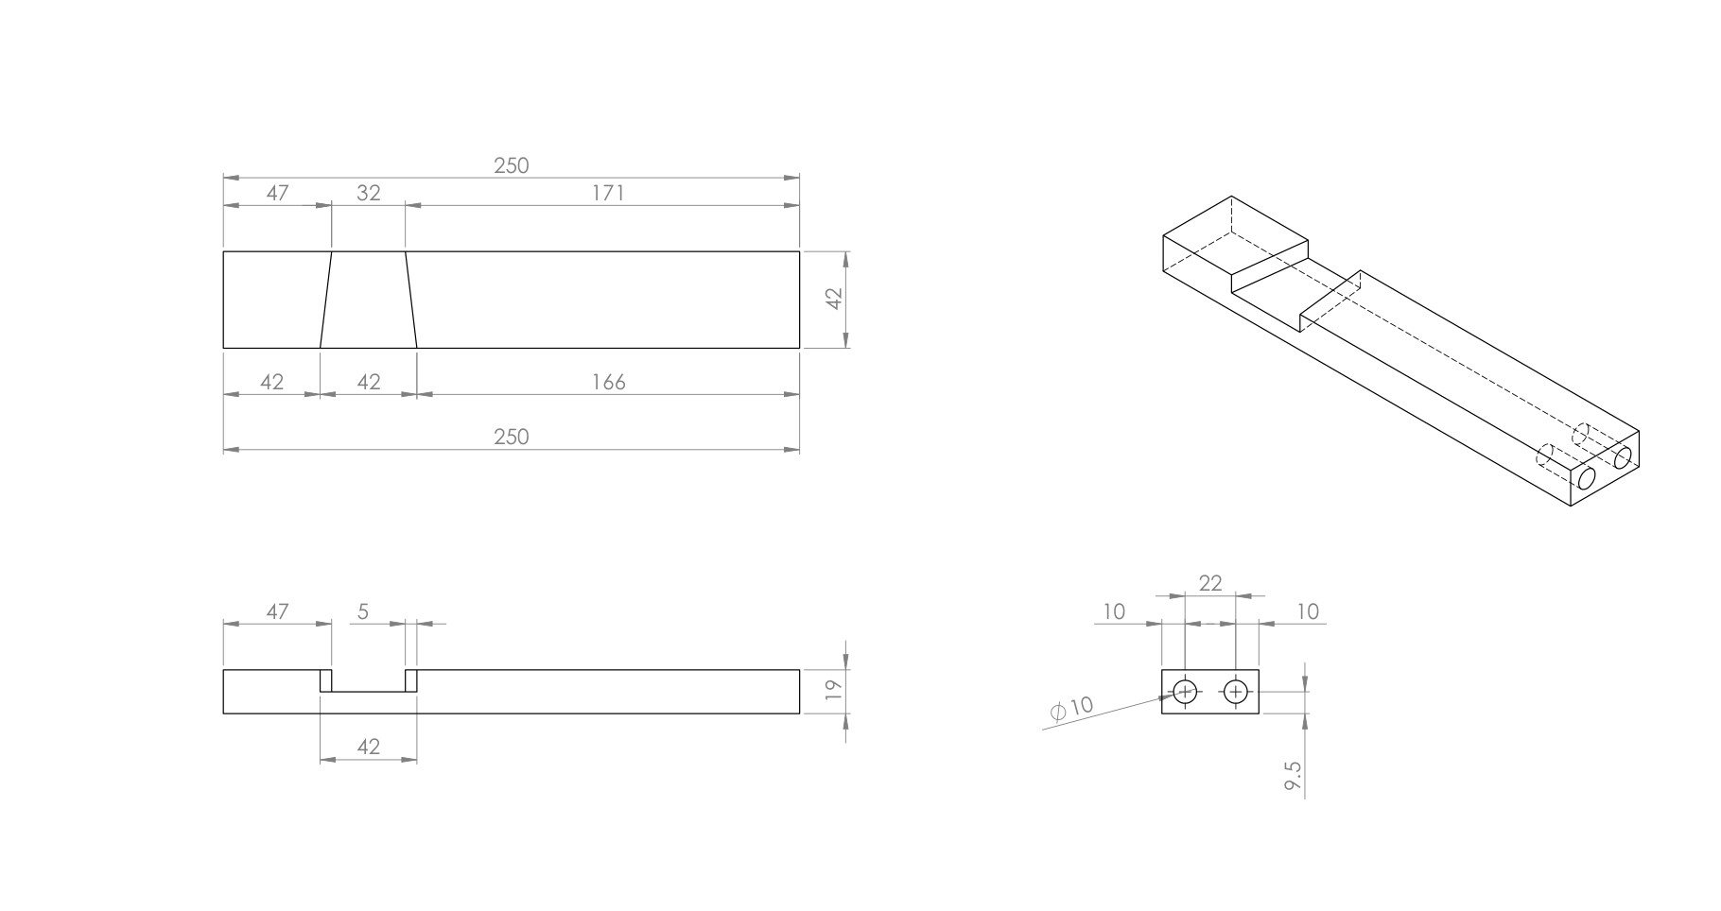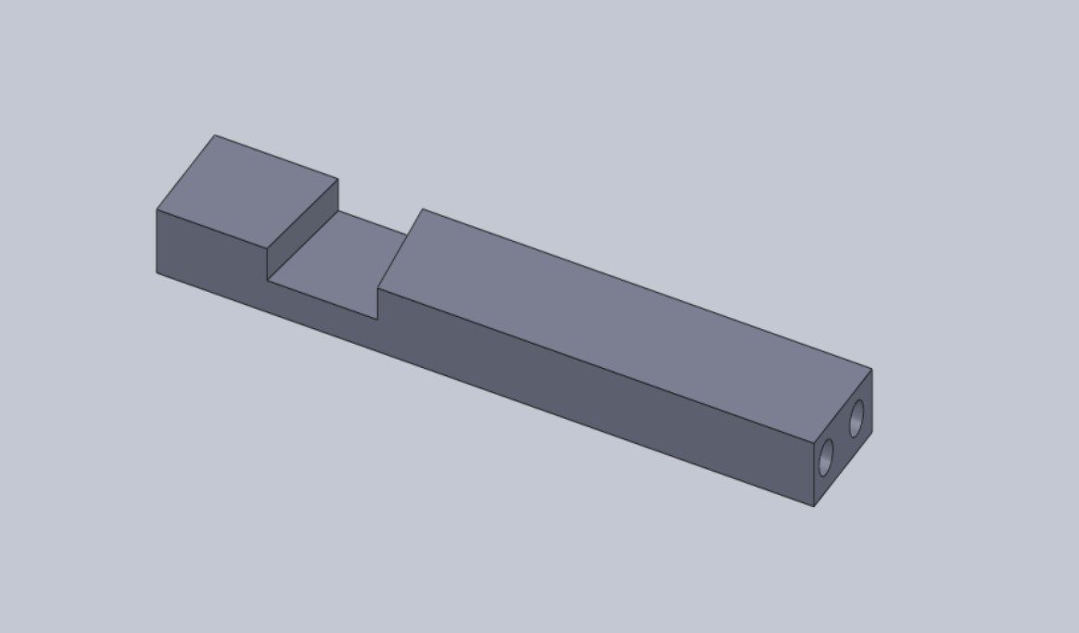Appropriate Industrial Processes and Equipment (Dovetail and Tenon)

Step one:
Take the Tasmanian oak and cut it into four equal parts of 250mm pieces. Tools/Justification:
Ruler (To measure in exact) Pencil (For marking and drawing) Try square (For straight lines)

Step two:
Mark out the dimensions for the Dovetail and tenon joint with a pencil, ruler and try square for perfect lines. The picture shows the dimensions used for both joint Tools/justification:
Ruler (to measure in exact) Pencil (For marking and drawing) Try square (For straight lines)

Step three:
Start off with the wood piece clamped into the vice with another wood block holding it. Take the tenon saw and slowly cut the sides of the dovetail. Make sure to always check if you have hit the halfway mark then stop. Repeat the step with the other side of the dovetail.
Tools/justification
Wooden block (A wood piece that helps support the wood piece when cutting for straight cuts)
The vice (to securely hold the wood piece in place)
Tenon saw (Used to cut timber)

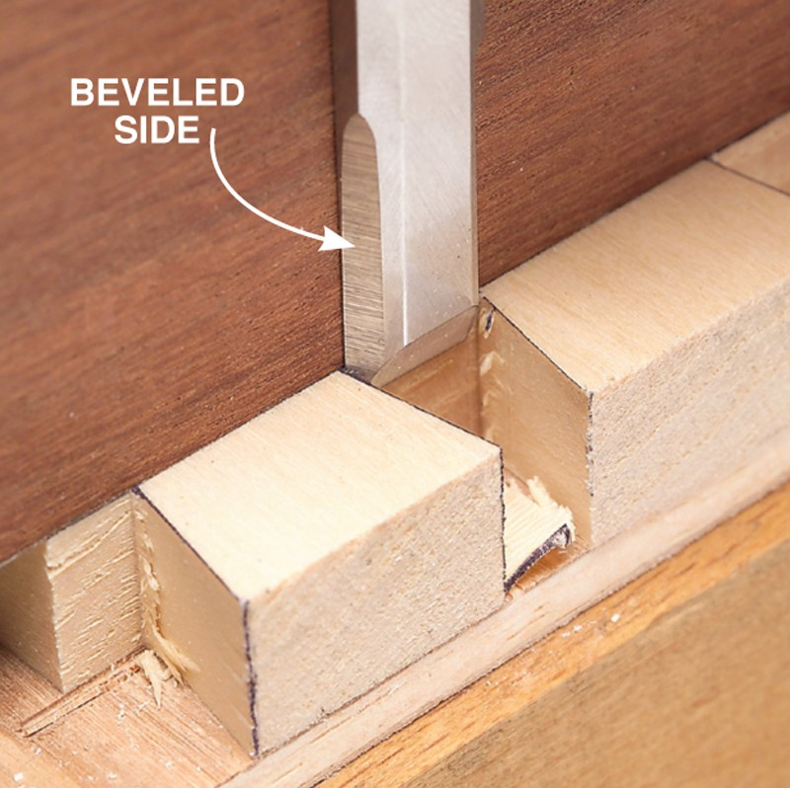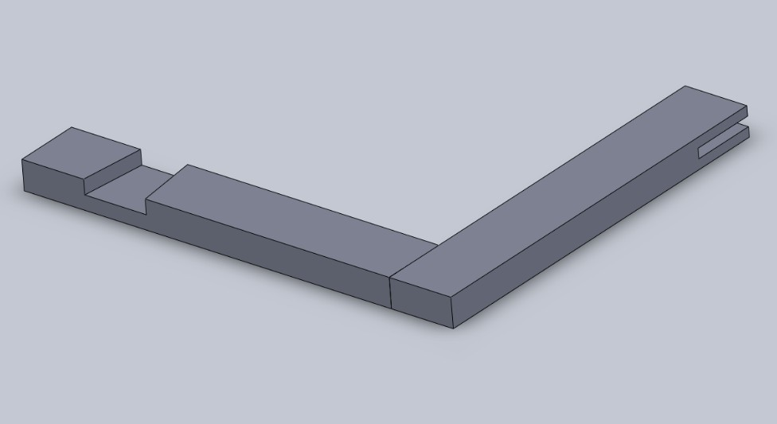Appropriate Industrial Processes and Equipment (Dovetail and Tenon continued)

Step four:
Repeat step four with the other side of the dovetail then take a sharp chisel and mallet and slowly chip the middle section of the dovetail. When chipping the woods away you must remember to chip a little section off, not in big chunks to avoid snapping the wood piece. Once this has completed make sure the dovetail fits and is nicely sanded with sanding paper.
Tools/justification
Chisel (To effectively chip the wood out) Mallet (A hammer used to work with a chisel for tapping)
Sanding paper (To sand away wood to make a clean cut)

Step five:
We then finish of this joint by completing the dowel joint on the other side of the piece. We make the 10mm holes by using the dowelling machine. We first place the wood piece into the machine by adjusting the measurements to fit your dimensions. Make sure you have your safety glasses on for protection. Any hair or tie should be tied up or tuck away. Then proceed into turning the machine on and slowly pulling the handle for the drill to go in. You must go slow in order for a clean cut. Tools/justification
Dowelling machine (A special machine used to make the perfect holes for dowelling)

Step six:
The last process of completing this joint is to make sure the cuts are straight and that the joint fits into one another. After dry assemble and glue with adhesives.

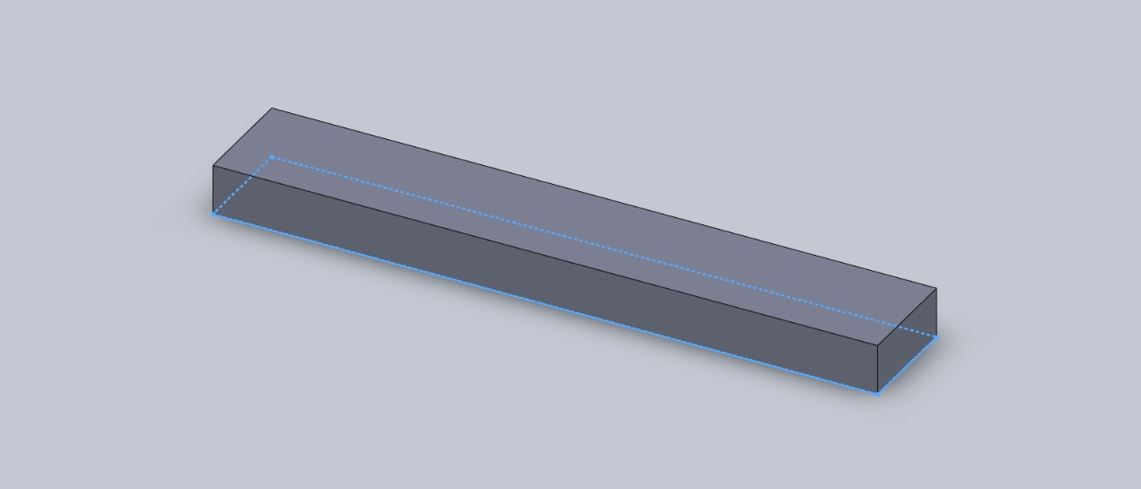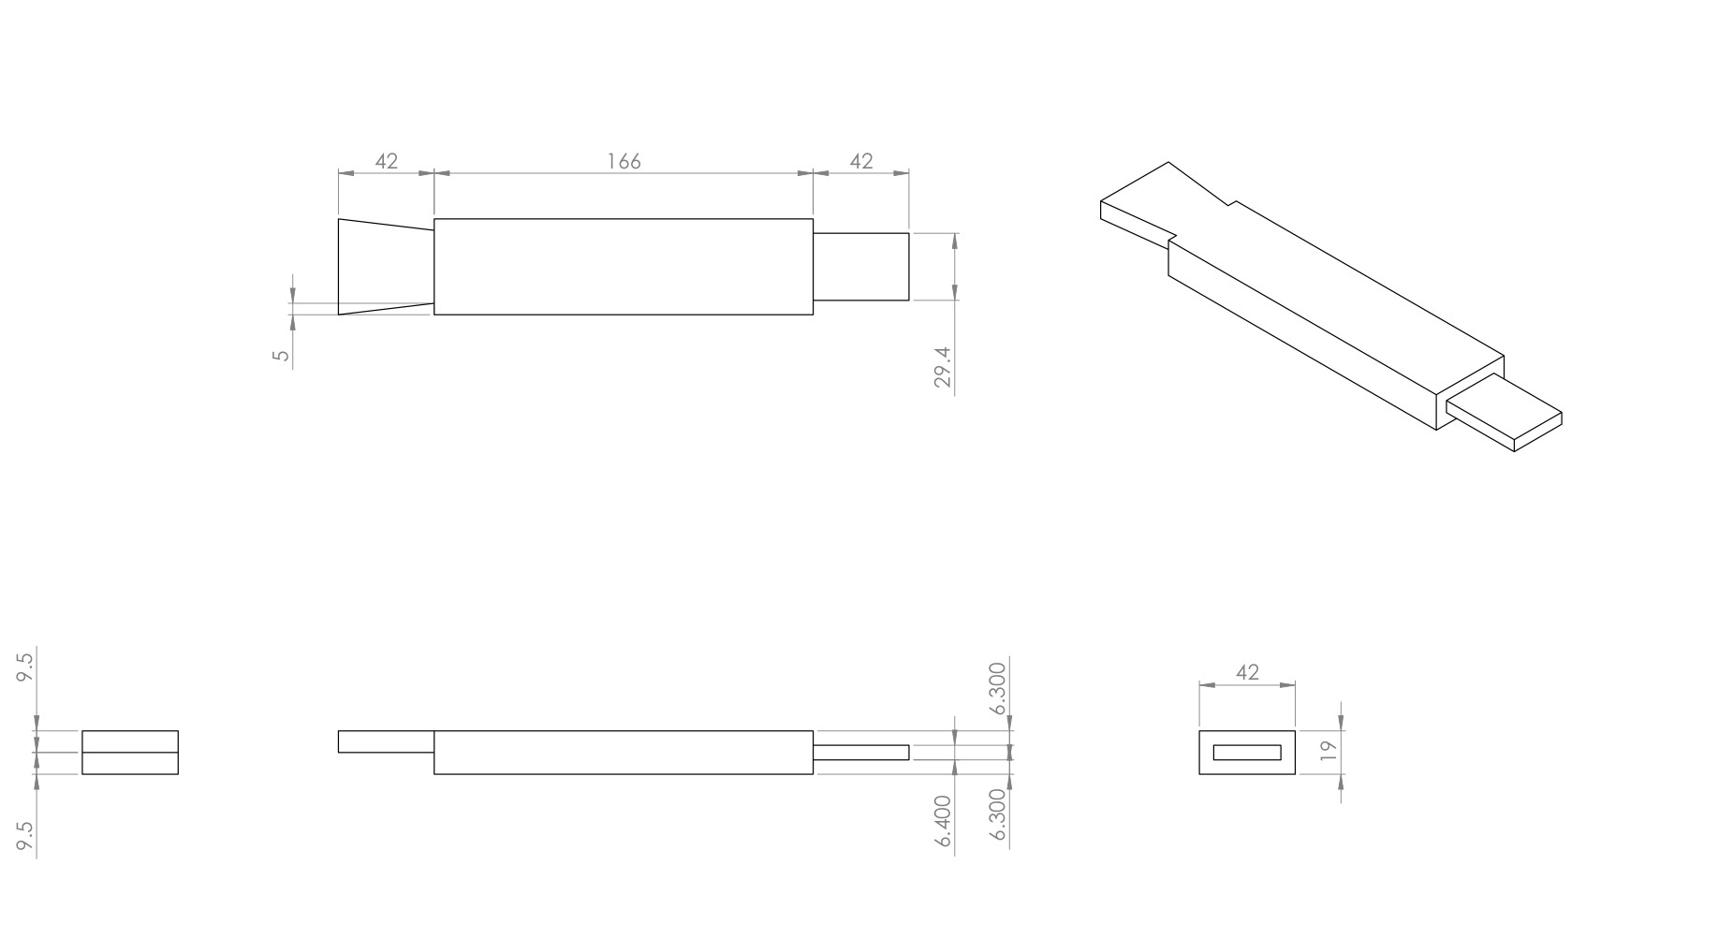Appropriate Industrial processes and equipment (Dovetail and Tenon)

Step one:
Take the Tasmanian oak and cut it into four equal parts of 250mm pieces. Tools/Justification:
Ruler (To measure in exact) Pencil (For marking and drawing) Try square (For straight lines)

Step two:
Mark out the dimensions for the Dovetail and Tenon joint with a pencil, ruler and try square for perfect lines. The picture shows the dimensions used for both joint Tools/justification:
Ruler (to measure in exact) Pencil (For marking and drawing) Try square (For straight lines)

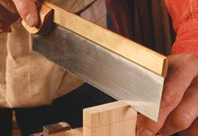Step three:
First start off with the wood piece in the vice with the dimensions for the dovetail on top vertically. Grab your tenon saw and saw the wood piece in half. Make sure you check every now and then for the end mark. Tools/justification
The vice (to securely hold the wood piece in place)
Tenon saw (Used to cut timber)

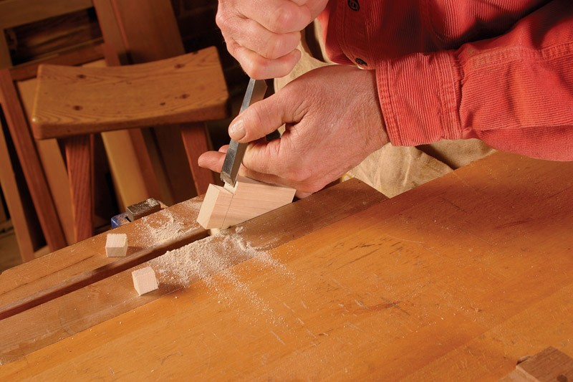Step four:
Place the wood piece with the cut did in step three into the vice on an angle like shown in the picture. Take a sharp chisel and slowly carve the wood till you get the perfect dovetail angle on both sides.
Tools/justification
The vice (To securely hold the wood piece in place)
Chisel (To effectively chip the wood out)

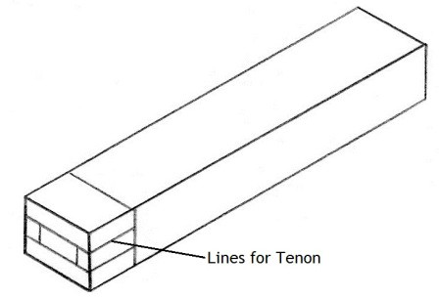Appropriate Industrial processes and equipment (Dovetail and Tenon continued)
jhowe
2015-05-18 23:38:01
--------------------------------------------
Excellent work here next time have real life pictures of yourself working for full marks.

Step five:
Last step is to make the mortise and tenon joint on the other side. We start off with the piece clamped into the vice and vertically upright. Cut the wood with a tenon saw with all the dimensions that are shown. Once you have finish cutting, it should look like a rectangle.
Tools/justification
The vice (to securely hold the wood piece in place)
Tenon saw (Used to cut timber)

Step six:
The last process of completing this joint is to make sure the cuts are straight and that the joint fits into one another. After dry assemble and glue with adhesives.

Safe Work Processes and WHS
jhowe
2015-05-18 23:38:26
--------------------------------------------
Well done

When using the equipment for wood industry, you need a variety of OnGuard tests to be completed. All students are to complete these before using any machines or equipment. In my case, I have evidence of completing all the OnGuard tests made by my teacher as seen below.

Safe Work Processes and WHS
jhowe
2015-05-18 23:39:00
--------------------------------------------
This picture has been used in all assessment task be careful in the future some teachers may mark you down for this.
jhowe
2015-05-18 23:40:05
--------------------------------------------
A table with all the tools listed and the safety procedures for each tool can make a document look professional. Well done though.

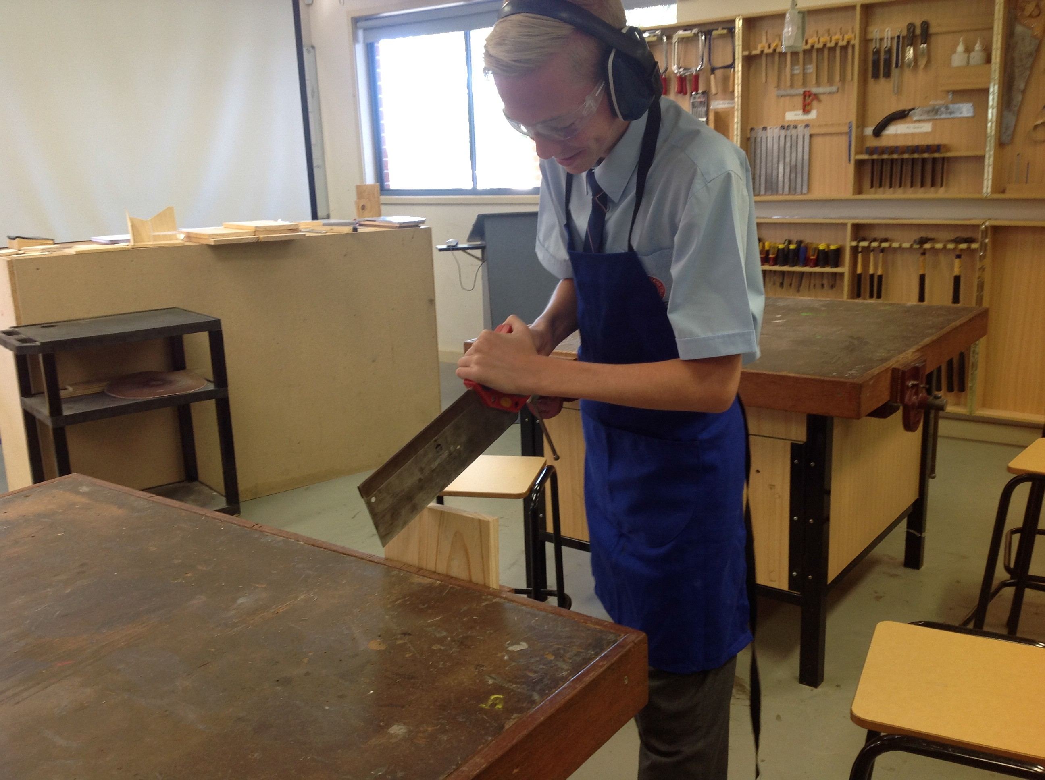As I complete these OnGuard tests I have understood the safe work practices when using the equipment. As you can see in the picture, we are wearing the right equipment when working in the work area. We are wearing the right leather shoes when using the saw, using an apron for protecting the school uniform and safety glasses for protection over the eyes.

Here at this school, they provide the best tools and equipment for students to use. We have learnt the safe way of handling all equipment and how to use them correctly. We have also be taught to use the machines correctly by using it under the permission of the teacher, by wearing an apron and safety glasses and by making sure no objects are in way of the machine.

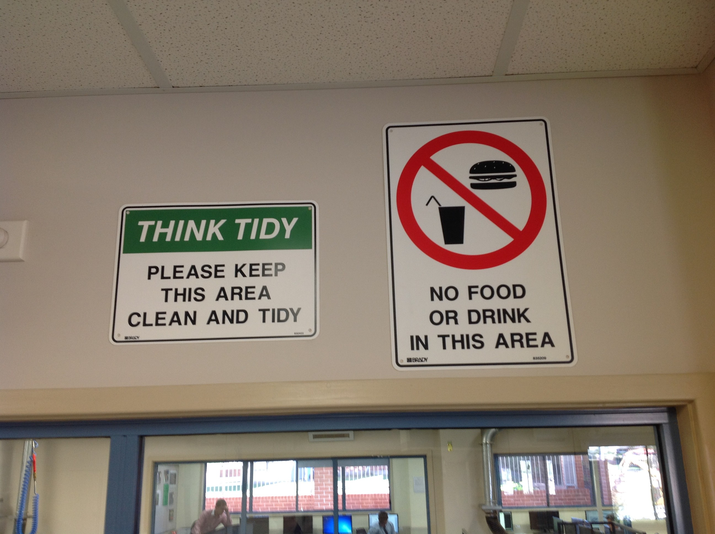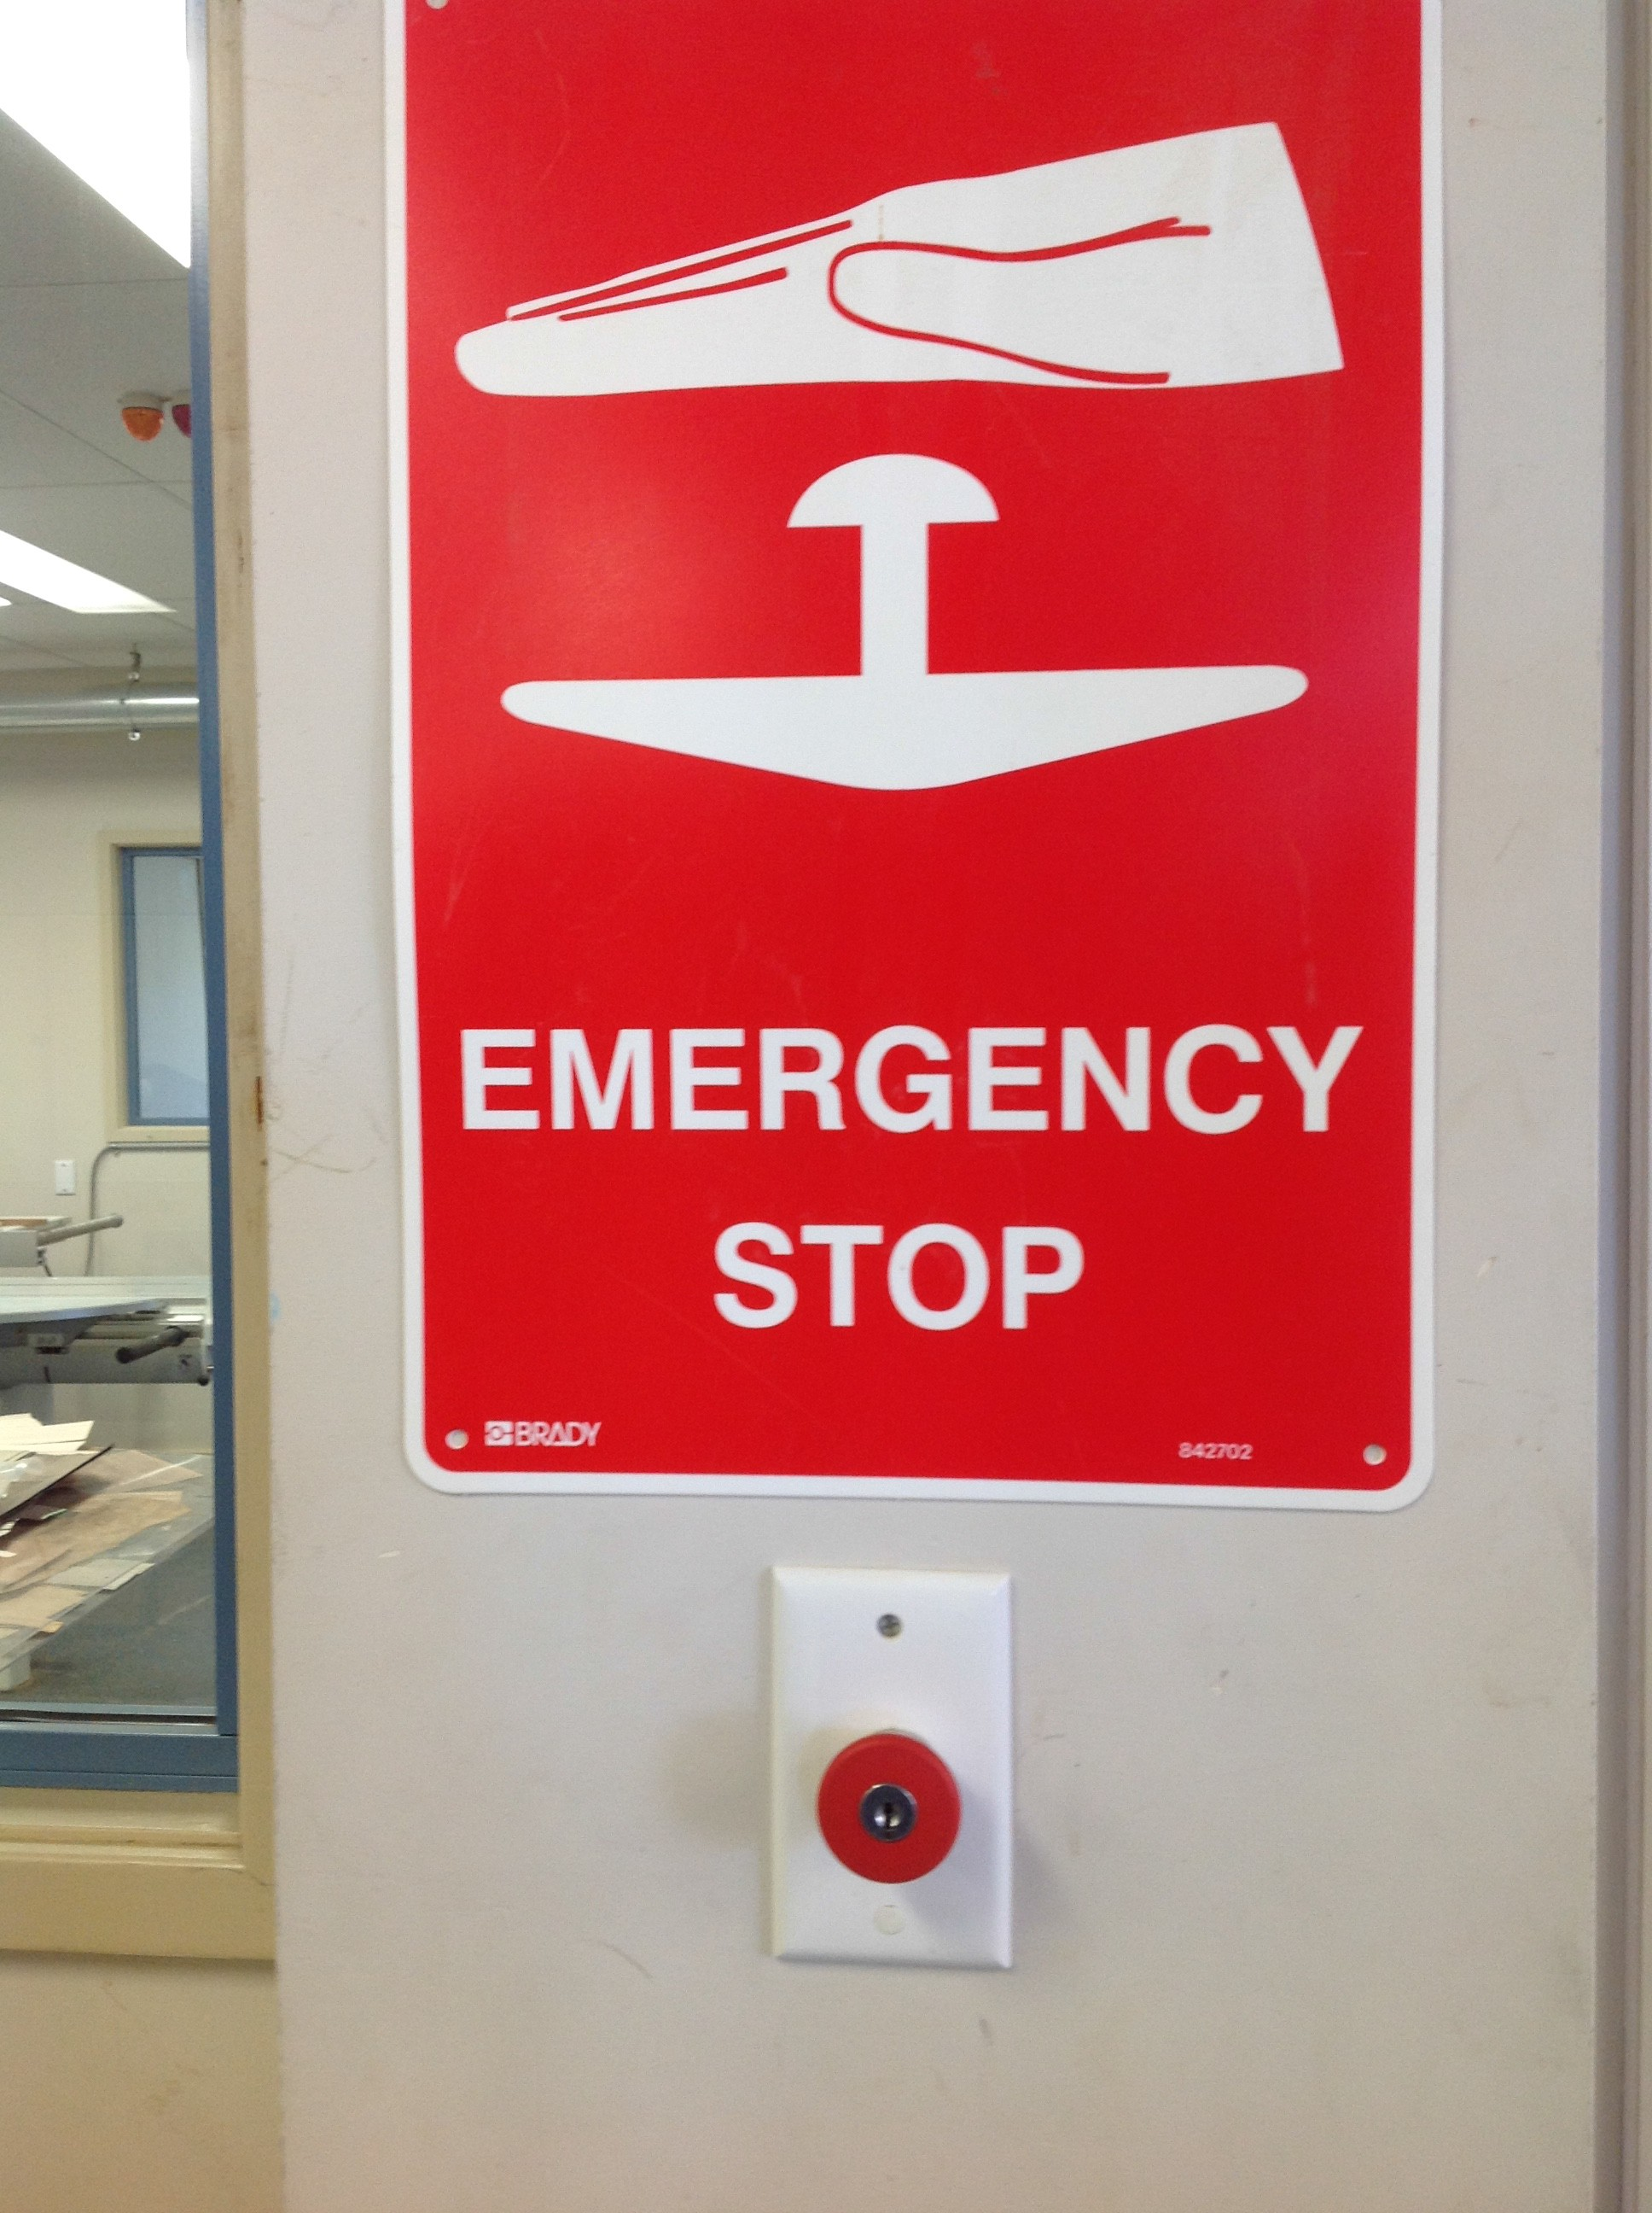The tools here at this workshop are very sharp and hazardous. This is why we have used the tools in a safe way. By holding the chisel with two hands or by wearing safety glasses. Not only do we have these safety rules but we have many signs and posters that remind us of safety hazards.

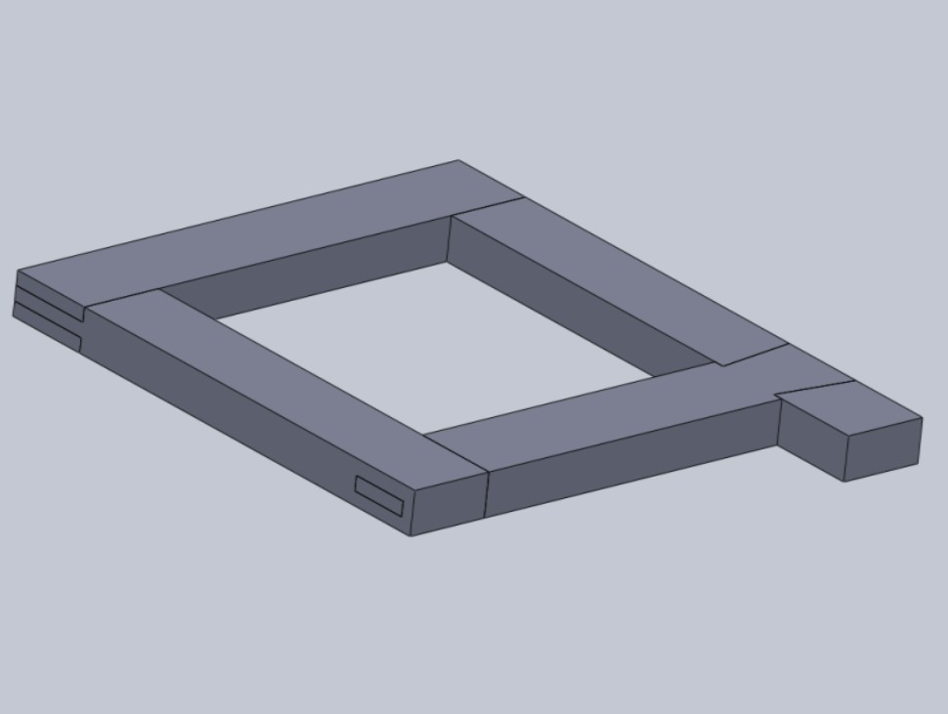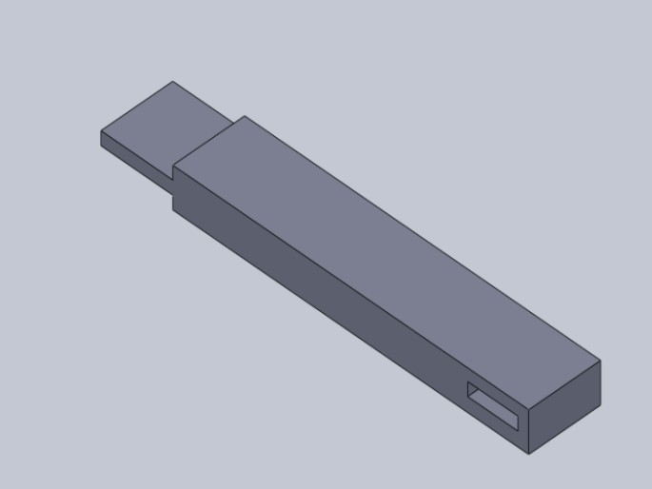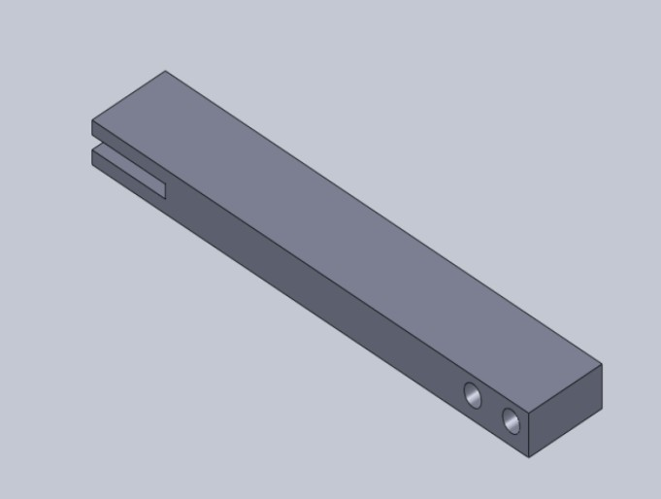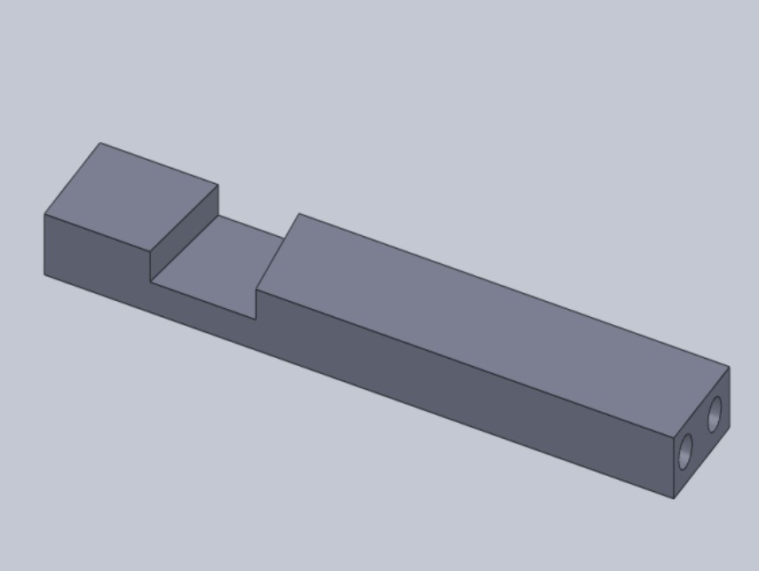Evidence of computer applications
jhowe
2015-05-18 23:40:27
--------------------------------------------
Next time label your pictures, well done.

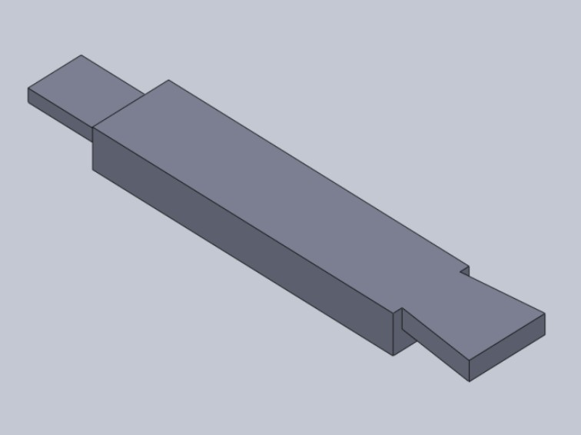When making the joint project it is important to fully understand the whole process of each joint and each measurements. This is why each student is to create the joint project onto a computer application such as solid works to create a virtual joint project. Using solid works is a helpful skill that could be used in future projects or jobs. As a class all students were to complete the joint project on solid works and show as an evidence for using a computer application. Here are photos of my solid work project as an evidence for using an application.

Bibliography
jhowe
2015-05-18 23:40:42
--------------------------------------------
Excellent well done.

Dovetail joint : Research en.wikipedia.org/wiki/dovetail_joint

http://www.woodworkbasics.com/dovetail-joint.html

http://www.technologystudent.com/joints/dovejts.htm

Mortise and tenon joint : Research http://www.woodworkbasics.com/mortise-and-tenon.html

http://www.dummies.com/how-to/content/tending-to-mortiseandtenon-joints.html

http://www.materialstechnologywood.com/practice-joints-mortice-and-tenon.php

Dowel joint : Research www.woodworkbasics.com/dowel-joint.html

www.materialstechnologywood.com/practice-joints-dowel-joints.php

http://en.m.wikipedia.org/wiki/Dowel

Bridle joint : Research http://www.woodworkbasics.com/bridle-joint.html

http://www.technologystudent.com/joints/brid1.htm

Textbook by Bruce Leadbeatter, Michael Leadbeatter, John Keable, Tony Clarke. 'Woodworking part one' textbook page. 125. 'Bridle Joint'

Financial Plan
http://www.barrenjoey timber.com.au/show.aspx? product=Tasmanian+Oak
+Dar&number=71&cat=13&catb=0

