THOMAS HASSALL ANGLICAN COLLEGE
Technology & Applied Studies
Year 10 Industrial Technology Timber
Research Task

Task: Manufactured Timber Products
Topic: Materials, Tools and Techniques
Weighting: 25%
Issue Date: Term 1 Week 3
Due Date: Thursday 30th March 2017 (Term 1, Week 9)

Areas of Assessment
Properties and applications of materials – Question 3, 5 and 6
Industrial Technology and society – Question 7, 8 and 10
Designing, communicating and evaluating – Question 1, 2, 4, 9 and 11

Outcomes:

5.3.1 justifies the use of a range of relevant and associated materials
5.3.2 selects and uses appropriate materials for specific applications
5.4.1 selects, applies and interprets a range of suitable communication techniques in the development, planning, production and presentation of ideas and projects
5.5.1 applies and transfers acquired knowledge and skills to subsequent learning experiences in a variety of contexts and projects
5.7.2 describes, analyses and evaluates the impact of technology on society, the environment and cultural issues locally and globally

Glossary of Key Terms

Describe Provide characteristics and features
Discuss Identify issues and provide points for and/or against
Explain Relate cause and effect; make the relationships between things evident; provide why and/or how
Identify Recognise and name
Outline Sketch in general terms; indicate the main features of

These key terms will be in BOLD text in each question

Assessment Guidelines
- Hand in your finished Assessment Task to your teacher on or before 8:15am on the due date.
- Plagiarism (directly copying work from an internet or book source or another student) is not acceptable and will receive a deduction of between 10% and 100% of the final mark depending on the nature of the malpractice.
- Late submission (tasks submitted after the submission time indicated above) will result in the deduction of 20% per day from the final mark.”
- Computer problems are not an acceptable excuse for the late submission of tasks. It is your responsibility to ensure that your work is ready to be presented/submitted (Save your work regularly on Google Drive or similar).
- Extensions will only be granted in exceptional circumstances by Mr. Stoker and must be requested by completing and submitting an Application for Assessment Task Extension form which can be found in the IRC.
- Please refer to the College Assessment Policy for further information.

Assessment Task Description

Manufactured timber products.

Choose one of the following materials below…

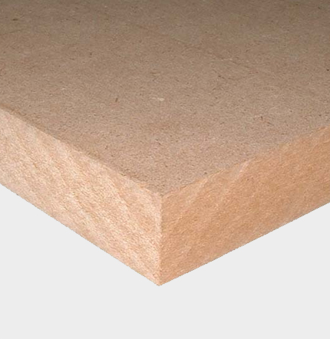
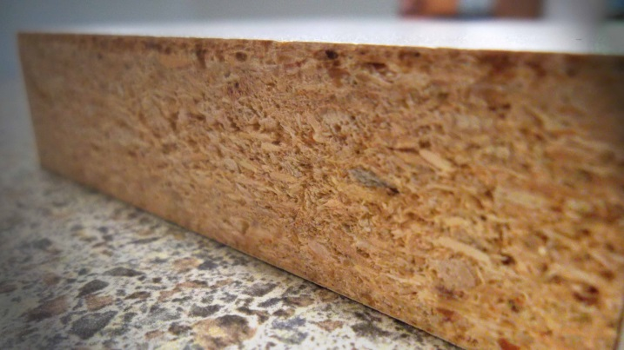
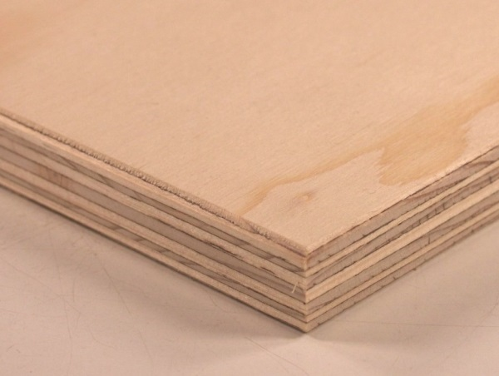
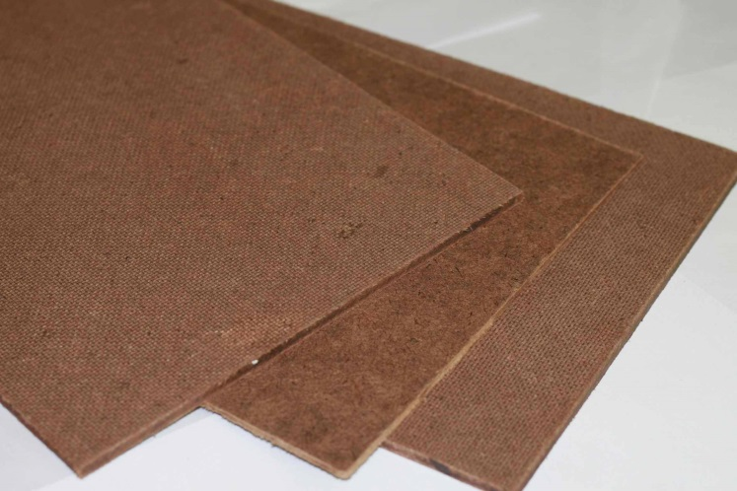

Hardboard
Particle Board
Plywood

Medium-density Fiberboard (MDF)

Provide information for your chosen timber product using the following scaffold:

- Title page (1 page). 5 marks

- Contents page (1 page). 5 marks

- Identify and describe the manufactured timber product (100 words). 10 marks

- Identify the manufacturing process using pictures to create a flowchart, including annotations (6 pictures minimum). 10 marks

- Discuss the advantages and disadvantages of using your chosen timber (100 words). 10 marks

- List, in a table the readily available sizes of your chosen timber 10 marks

- Identify and describe any tooling or machines used when manufacturing a product using your chosen timber (100 words). 10 marks

- List and describe products/furniture manufactured from your chosen timber. (100 words). 10 marks

- Identify products which have been manufactured using your chosen timber product (3 products minimum). 5 marks

- Explain how the use of your chosen timbers impacts on society and the environment, locally and globally (250 words). 20 marks

- Reference list 5 marks

These things need to be in your assessment task

Resources:

Woodworking part one (chapter 2) Author: Leadbeatter
Internet websites
Furnishing – an industry study for secondary schools Author: Schlyder

Marking Guide

- Title page (1 page)
- Contents page (1 page)
Outcome | Criteria | Mark out of 10 | Comment
5.4.1 | Professional title page and contents page, page numbers match contents page clear and easily understood by reader. | 8-10
 | Excellent title page and contents page, page numbers match contents page clear and easily understood by reader. | 6-7
 | Satisfactory title page and contents page, page numbers match contents page clear and easy to understand. | 4-5
 | Average title page and contents page, page numbers somewhat matches contents page can identify page number with contents page. | 2-3
 | Outcome not met. | 0-1

- Identify and describe the manufactured timber product (100 words).
Outcome | Criteria | Mark out of 10 | Comment
5.3.1 | - Clearly recognizes and names a manufactured timber product from the given list.  - Clearly provides characteristics and features of the manufactured timber product.  - 100 or more words for description using clear and concise industry appropriate language to describe the timber. | 8-10
 | - Recognizes and names a manufactured timber product from the given list.  - Provides characteristics and features of the manufactured timber product.  - 100 words for description using clear industry appropriate language to describe the timber. | 6-7
 | - Recognize or name a manufactured timber product from the given list.  - Provides characteristic or feature of the manufactured timber product.  - Less than 100 words for description using some industry appropriate language to describe the timber. | 4-5
 | - Does not clearly recognize or name a manufactured timber product from the given list.  - Does not provide a characteristic or feature of the manufactured timber product.  - Less than 100 words for description not using industry appropriate language to describe the timber. | 2-3
 | Outcome not met. | 0-1
- Identify the manufacturing process using pictures to create a flowchart, including annotations (6 pictures minimum).
Outcome | Criteria | Mark out of 10 | Comment
5.3.1 | - Clearly recognizes and names the manufacturing process of the manufactured timber product providing 6 pictures or more.  - Provides clear and easy to read flowchart including annotations. | 8-10
 | - Recognizes and names the manufacturing process of the manufactured timber product providing 6 pictures.  - Provides easy to read flowchart including annotations. | 6-7
 | - Recognizes or names the manufacturing process of the manufactured timber product providing less than 4 pictures.  - Provides flowchart including some annotations. | 4-5
 | - Does not clearly recognizes or names the manufacturing process of the manufactured timber product providing less than 2 pictures.  - Provides some sections of a flowchart including no or little annotations. | 2-3
 | Outcome not met. | 0-1

- Discuss the advantages and disadvantages of using your chosen timber (100 words)
Outcome | Criteria | Mark out of 10 | Comment
5.5.1 | - Clearly identifies points for and against in direct relation to the manufactured timber product.  - Provides 8 points related to the manufactured timber product using 100 words or more. | 8-10
 | - Identifies points for and against in relation to the manufactured timber product.  - Provides 6-7 points related to the manufactured timber product using 100 words. | 6-7
 | - Identifies points for or against in relation to the manufactured timber product.  - Provides 4-5 points related to the manufactured timber product using 80 words or less. | 4-5
 | - Identifies points for or against in relation to the manufactured timber product.  - Provides 2-3 points related to the manufactured timber product using 50 words or less. | 2-3
 | Outcome not met. | 0-1

- List the available sizes of your chosen timber
Outcome | Criteria | Mark out of 10 | Comment
5.3.2 | - Clearly indicates the available sizes and thicknesses of the manufactured timber product.  - Clearly sketches in general terms the location/store to buy product including a price list. | 8-10
 | - Indicates the available sizes and thicknesses of the manufactured timber product.  - Sketches in general terms the location/store to buy product including a price list. | 6-7
 | - Indicates the available sizes or thicknesses of the manufactured timber product.  - Sketches in general terms the location/store to buy product, does not include a price list. | 4-5
 | - Indicates some available sizes or thicknesses of the manufactured timber product.  - Does not clearly sketch in general terms the location/store to buy product, does not include a price list. | 2-3
 | Outcome not met. | 0-1

- Identify and describe any tooling and machines used when manufacturing a product using your chosen timber (100 words).
Outcome | Criteria | Mark out of 10 | Comment
5.5.1 | - Clearly recognizes and names tooling and machines used in manufacturing a product using the manufactured timber product.  - Clearly provides characteristics and features of the tooling and machines used in manufacturing a product using the manufactured timber product. | 8-10
 | - Recognizes and names tooling and machines used in manufacturing a product using the manufactured timber product.  - Provides characteristics and features of the tooling and machines used in manufacturing a product using the manufactured timber product. | 6-7
 | - Recognizes or names tooling and machines used in manufacturing a product using the manufactured timber product.  - Provides characteristics or features of the tooling and machines used in manufacturing a product using the manufactured timber product. | 4-5
 | - Recognize or name a tool or machine used in manufacturing a product using the manufactured timber product.  - Provide characteristic or feature of a tool or machine used in manufacturing a product using the manufactured timber product. | 2-3
 | Outcome not met. | 0-1

- List and describe products/furniture manufactured from your chosen timber. (100 words).
Outcome | Criteria | Mark out of 10 | Comment
5.3.2 | - Clearly provides characteristics and features of products/furniture manufactured from you manufactured timber product using 100 words or more. | 8-10
 | - Provides characteristics and features of products/furniture manufactured from you manufactured timber product using 100 words. | 6-7
 | - Provides characteristics or features of products/furniture manufactured from you manufactured timber product using 80 words or less. | 4-5
 | - Provides a characteristic or feature of products/furniture manufactured from you manufactured timber product using 50 words or less. | 2-3
 | Outcome not met. | 0-1

- Identify products which have been manufactured using your chosen timber product (3 products minimum).
Outcome | Criteria | Mark out of 5 | Comment
5.3.1 | - Clearly recognizes and names products which have been manufactured with chosen timber including 5 pictures and clearly labelled annotations. | 5
 | - Recognizes and names products which have been manufactured with chosen timber including 4 pictures and labelled annotations. | 4
 | - Recognize or name products which have been manufactured with chosen timber including 3 pictures and some labelled annotations. | 3
 | - Recognize or name a product which have been manufactured with chosen timber including less than 3 pictures with no annotations. | 2
 | Outcome not met. | 0-1

- Explain how your chosen timbers impacts on society and the environment, locally and globally (250 words).
Outcome | Criteria | Mark out of 20 | Comment
5.7.2 | - Clearly makes the relationship evident between the manufactured timber product; clearly providing how and why it impacts on society and the local and global environment. | 16-20
 | - Makes the relationship evident between the manufactured timber product; provides how and why it impacts on society and the local and global environment. | 12-15
 | - Satisfactorily makes the relationship between the manufactured timber product; provides how or why it impacts on society and the local and global environment. | 8-11
 | - Basically makes the relationship between the manufactured timber product; provides how or why it may impact on society and the local and global environment. | 4-7
 | Outcome not met. | 0-3

- Reference list
Outcome | Criteria | Mark out of 5 | Comment
5.4.1 | - Extensively referenced to Thomas Hassall referencing style provided on page 10 of assessment task. | 5
 | - Thoroughly referenced to Thomas Hassall referencing style provided on page 10 of assessment task. | 4
 | - Adequately to Thomas Hassall referencing style provided on page 10 of assessment task. | 3
 | - Basically referenced to Thomas Hassall referencing style provided on page 10 of assessment task. | 2
 | Outcome not met. | 0-1

Referencing guideline
Book Entry – Single Author
Author or editor and initial, date, name of book underlined or italics, place of publication, publishing company, page numbers.
Example:
Arnheim, R. (1971). Art and Visual Perception. Berkeley: University of NSW, Press. p 255.
Multiple Authors
When a work has up to and including 3 authors, cite all authors. When a work has more than 3 authors cite the first 3 followed by "et al".
Citing Chapters in an Edited Book
Author, initial, date, year, title; cited in, initials, author, date, title, pages, place of publication, publisher.
Example:
Rubenstein, J.P. (1967). The effect of television violence on small children. In B.F.Kane (Ed.), Television and juvenile psychological development (pp.112-134). New York. American Psychological Society.

Journal Article in Electronic Database
Author, initials, year, 'Article title', Journal Title, volume, issue, paging (if given), viewed day month year, name of database service, name of database, item number (if given).
Example:
Rasid, ZM & Parish, TS 1998, 'The effects of training students' levels of adherence', Adolescence, vol. 33, no. 129, p. 99, viewed 23 September 2007, EBSCOhost MegaFILE Premier, Academic Search Premier, item: AN589758

Internet / World Wide Web Sources
Author's surname, initial, title (italicised), date of Internet publication, date of access <URL>. GENERAL WEBSITE.
Example:
Brenner, A., (1995). The Murder Trial. Accessed on 23/10/09 from http://englishserver

Online Images
Figure captions should be directly under the image and then followed by an in-text citation.
Figure 1: Consumer confidence, concerns, spending and attitudes to recession: a global Nielsen consumer report (AC Nielsen 2008).

