Year 9 Industrial Technology Class Task 2
Name the marking out tools, hand tool and describe what it is used for…
1. Marking out equipment
Name: ______________________________
Description: __________________________
____________________________________
____________________________________
____________________________________
____________________________________
____________________________________
____________________________________

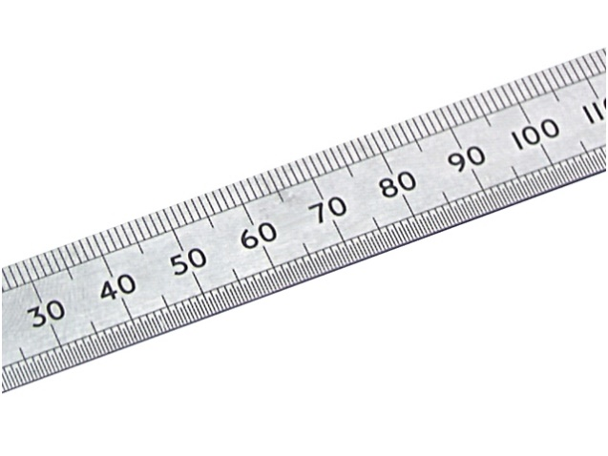
Name: ______________________________
Description: __________________________
____________________________________
____________________________________
____________________________________
____________________________________
____________________________________
____________________________________

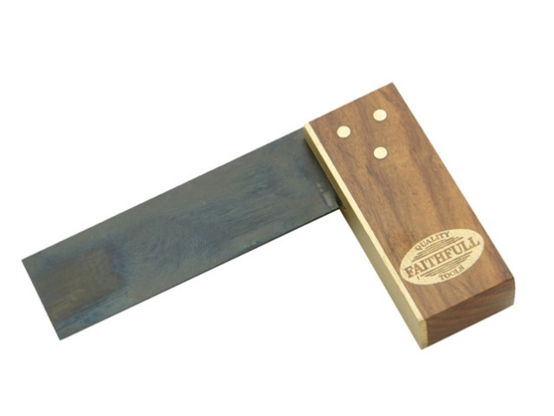
Name: ______________________________
Description: __________________________
____________________________________
____________________________________
____________________________________
____________________________________
____________________________________
____________________________________

1. Shaping and drilling
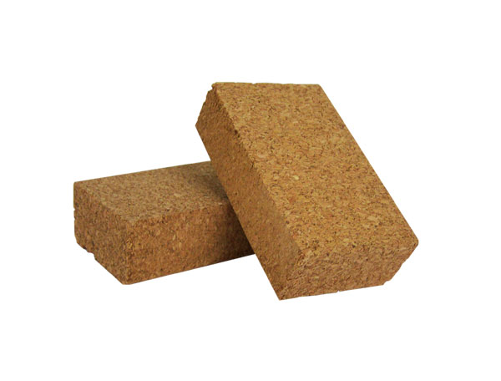
Name: ______________________________
Description: __________________________
____________________________________
____________________________________
____________________________________
____________________________________
____________________________________
____________________________________

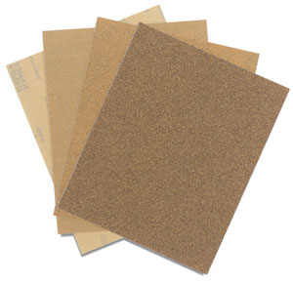
Name: ______________________________
Description: __________________________
____________________________________
____________________________________
____________________________________
____________________________________
____________________________________
____________________________________

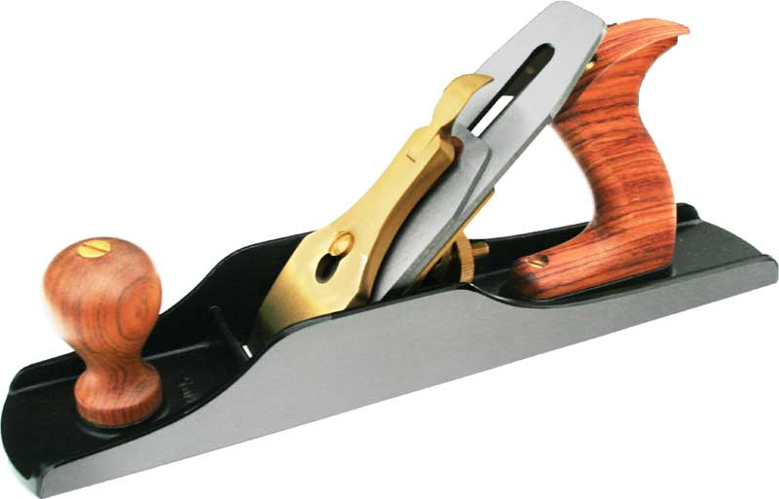
Name: ______________________________
Description: __________________________
____________________________________
____________________________________
____________________________________
____________________________________
____________________________________
____________________________________

