Year 9 Industrial Technology Class Task 1
Fill in the missing spaces of this cross section…

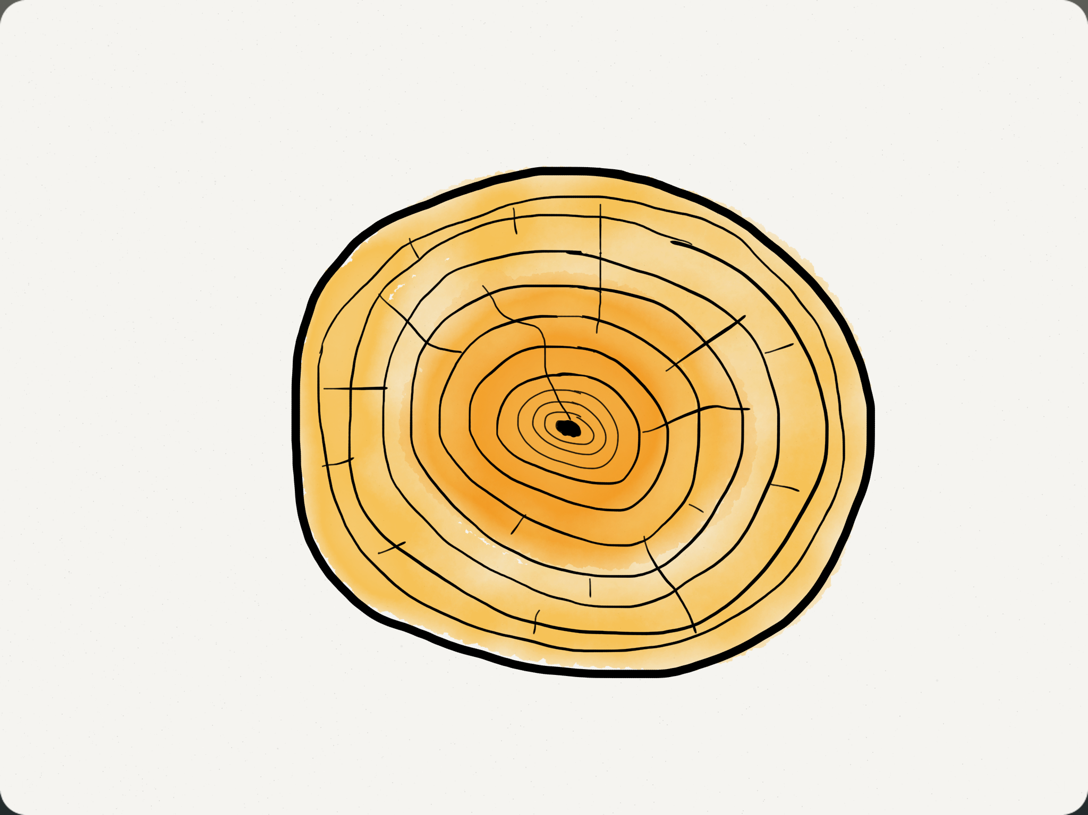

Cross Section

Put these words in the spaces above…
- Cambium Layer 6. Sapwood
- Bark 7. Growth rings
- Pith or medulla 8. Summer wood
- Trunk 9. Spring wood (latewood)
- Heartwood 10. Medullary rays

