Advice of Year 9 Assessment Task One

Subject/Course: Industrial Technology - Timber

“Multi Joint Frame”

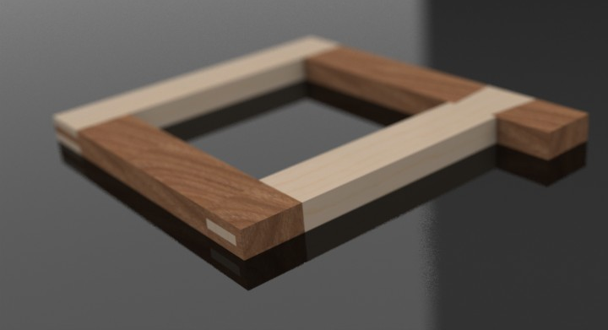

The Assessment Task is required to be completed at home. Some class time will be allocated to the completing of the task. Submission is required on Monday April 4th by 2:40pm.

The teacher will advise you of the periods available where you can work on your assessment task.

Weighting of Assessment: 25%

Total Marks: 100. (Practical project 60%, Practical portfolio 40%)

Outcomes being assessed:

5.1.1 | identifies, assesses and manages the risks and OHS issues associated with the use of a range of materials, hand tools, machine tools and processes
5.1.2 | applies OHS practices to hand tools, machine tools, equipment and processes
5.2.2 | identifies, selects and competently uses a range of hand and machine tools, equipment and processes to produce quality practical projects
5.4.1 | selects, applies and interprets a range of suitable communication techniques in the development, planning, production and presentation of ideas and projects
5.4.2 | works cooperatively with others in the achievement of common goals
5.5.1 | applies and transfers acquired knowledge and skills to subsequent learning experiences in a variety of contexts and projects
5.6.1 | evaluates products in terms of functional, economic, aesthetic and environmental qualities and quality of construction

Portfolio 40%
Your portfolio is to include the following headings. See below for a brief description of the sort of information that could be expected under each heading.

Design
- Statement of intent
- Research

Management and Communication
- Finance Plan
- Use of appropriate industrial processes and equipment
- Evidence of safe work processes and WHS issues
- Evidence of a range of computer applications

Practical Task 60%
You are required to Create a 4 Joint frame. You are to use hand tools. The details are enclosed within the document posted on the thacindtech.weebly.com website. See the project sheet for all details including engineering drawings and workflow diagrams.

Folio Headings
Design
- Statement of intent
  - Provide a clear statement of the project. What it is and why you are making it.
- Research
  - Research each joint type.
  - Include advantages and disadvantages of each joint style.
  - Include samples of where each joint would be successfully used.
  - Include pictures.
  - Use a range of research sources and media for best results. Use at least 2 sources to compare results.
  - Include ‘reference’ or ‘citation’ where necessary to avoid plagiarism.

Management and Communication
- Finance Plan
  - Actual cost.
- Use of appropriate industrial processes and equipment
  - What industrial processes been utilised in the production.
  - Are they appropriate? Discuss.
- Evidence of safe work processes and WHS issues
  - Evidence of safe working procedures.
  - Photographic or written.
  - List relevant WHS regulations that apply.
- Evidence of a range of computer applications
  - Evidence of computer applications including:
    - Word processing.
    - Spreadsheets.
    - CAD.
    - Multimedia.

Please see marking criteria for further detail.

