THOMAS
HASSALL
ANGLICAN
COLLEGE

Year 11 Industrial Technology Portfolio Workbook
Time and Finance Plan

Student Name: ___________________________
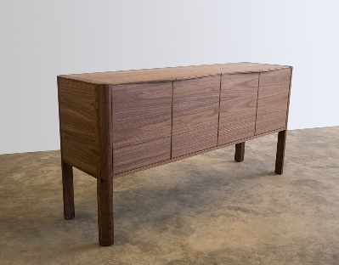
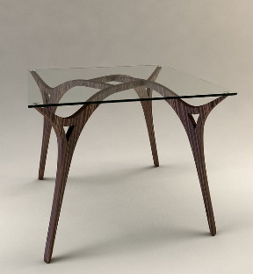
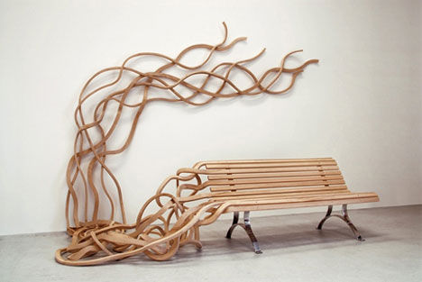
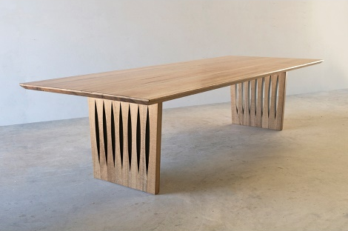
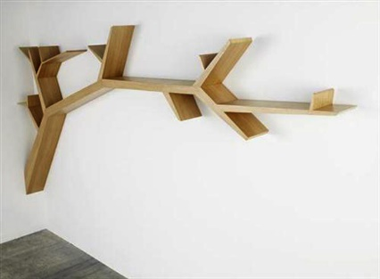
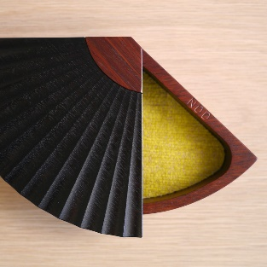
Contents
Design and Management 3
Time Plan General Overview 3
Term Planner 5
Finance Plan 10
How to cost a project 10

Design and Management

Time Plan General Overview

This section is planning your project in sections…

Process | Term 4 - 2016 | Term 1 - 2017 | Term 2 - 2017 | Term 3 - 2017
Process 1
Process 2
Process 3
Process 4
Process 5

Process 6

Process 7

Process 8

Ongoing Evaluation – what things do you need to achieve to make these processes happen?
________________________________________________________________________________________________________________________________________________________________________________________________________________________________________________________________________________________________________________________________________________________________________________________________________________________________________________________________________________________________________________________________________________________________________________________________________________________________________________________________________________________________________________________________________________________________________________________________________________________________________________________________________________________________________________________________________________________________________________________________________________________________________________________

Term Planner

This section is to plan each term in more detail so you can follow this guide throughout the year…

Term 4 - 2016 | Week 1 | Week 2 | Week 3 | Week 4 | Week 5 | Week 6 | Week 7 | Week 8 | Week 9 | Week 10 | Week 11
Process 1
Process 2
Process 3
Process 4
Process 5

Ongoing Evaluation – what are the things you need to do this term to complete you action plan…
________________________________________________________________________________________________________________________________________________________________________________________________________________________________________________________________________________________________________________________________________________________________________________________________________________________________________________________________________________________________________________________________________________________________________________________________________________________________________________________________________________________________________________________________________________________________________________________________________________________________________________________________________________________________________________________________________________________________________________________________________________________________________________________

Term 1 - 2017 | Week 1 | Week 2 | Week 3 | Week 4 | Week 5 | Week 6 | Week 7 | Week 8 | Week 9 | Week 10 | Week 11
Process 1
Process 2
Process 3
Process 4
Process 5

Ongoing Evaluation – what are the things you need to do this term to complete you action plan…
____________________________________________________________________________________________________________________________________________________________________________________________________________________________________________________________________________________________________________________________________________________________________________________________________________________________________________________________________________________________________________________________
Term 2 - 2017 | Week 1 | Week 2 | Week 3 | Week 4 | Week 5 | Week 6 | Week 7 | Week 8 | Week 9 | Week 10 | Week 11
Process 1
Process 2
Process 3
Process 4
Process 5

Ongoing Evaluation – what are the things you need to do this term to complete you action plan…
____________________________________________________________________________________________________________________________________________________________________________________________________________________________________________________________________________________________________________________________________________________________________________________________________________________________________________________________________________________________________________________________
Term 3 - 2017 | Week 1 | Week 2 | Week 3 | Week 4 | Week 5 | Week 6 | Week 7 | Week 8 | Week 9 | Week 10 | Week 11
Process 1
Process 2
Process 3
Process 4
Process 5

Ongoing Evaluation – what are the things you need to do this term to complete you action plan…
____________________________________________________________________________________________________________________________________________________________________________________________________________________________________________________________________________________________________________________________________________________________________________________________________________________________________________________________________________________________________________________________

Finance Plan

How to cost a project

We always need to plan a project before just jumping in, this helps to ensure both a quality project but also that 1. We don’t run out of material and 2. It doesn’t cost more than we expected.

The table below has six criteria that need to be filled out to thoroughly plan the requirements of materials for a project. This simple format can also be simply interpreted by anybody else reading your calculations.

Description: This is the name of the component.
Length: The length of the component, specified in mm or M.
No. off: How many of the items need to be produced.
Meters: This is a sum. (No. off x Length = Total Meters)
Cost/Meter: The cost of the material ‘per Meter’
Cost: This is a sum. (Meters x Cost/Meter = Total cost)

The below example will calculate the cost of a simple Hall Table.

Description |  | Timber |  | Length |  |  | Quantity |  | Meters |  | Cost/meter |  | Cost
Table Top |  | Pine |  | 600mm |  |  | 3 |  | 1.8 |  | $22.50 |  | $40.50
Short rails |  | Pine |  | 300mm |  |  | 2 |  | 0.6 |  | $5.40 |  | $3.24
Long rails |  | Pine |  | 500mm |  |  | 2 |  | 1.0 |  | $5.40 |  | $5.40
Tapered legs |  | Pine |  | 600mm |  |  | 4 |  | 2.4 |  | $7.20 |  | $17.28
Feature piece |  | Pine |  | 300mm |  |  | 1 |  | 0.3 |  | $5.40 |  | $1.62
Total Cost |  |  |  |  |  |  |  |  |  |  |  |  | $68.04
Parts List
Description | Timber |  | Length |  | Width | Quantity |  | Meters |  | Cost/metre |  | Cost
Total Cost

Parts List
Description | Timber | Length | Width | Quantity | Meters | Cost/metre | Cost
Total Cost

Ongoing Evaluation – what are the things you need to do this term to complete your finance plan…
____________________________________________________________________________________________________________________________________________________________________________________________________________________________________________________________________________________________________________________________________________________________________________________________________________________________________________________________________________________________________________________________

Components List
Description | Timber | Length | Width | Quantity | Meters | Cost/metre | Cost
Total Cost

Fixings and Fasteners
Description | Timber | Length | Width | Quantity | Meters | Cost/metre | Cost
Total Cost

Ongoing Evaluation – what are the things you need to do this term to complete your finance plan…
____________________________________________________________________________________________________________________________________________________________________________________________________________________________________________________________________________________________________________________________________________________________________________________________________________________________________________________________________________________________________________________________

