THOMAS
HASSALL
ANGLICAN
COLLEGE

Year 11 Industrial Technology Portfolio Workbook
Selection and Justification of Materials

Student Name: ___________________________
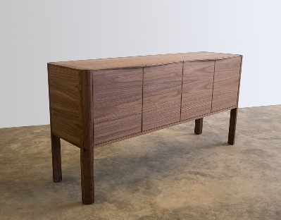
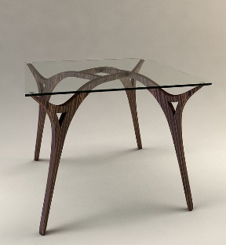
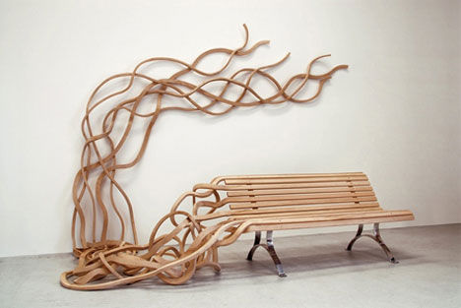
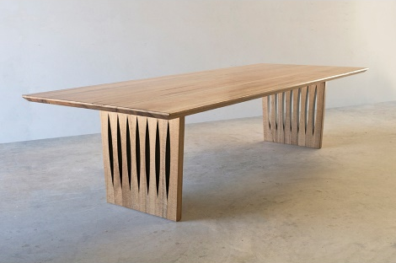
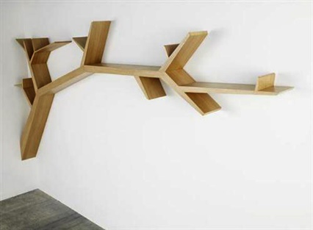
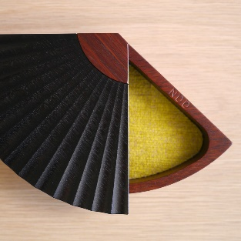
Contents
Design 3
Materials 3
Components 5
Processes 7
Resources 9
Other things like templates 11

Design

Materials

This section is for researching what the best material to use for each part of your project, like caracse, drawers, glass or doors…

Project Part | Material options | Material Choice, possibly a picture of the material… | Where to access this material | Why have I chosen this material…

Ongoing Evaluation – what are the things you need to do for ordering your materials?
________________________________________________________________________________________________________________________________________________________________________________________________________________________________________________________________________________________________________________________________________________________________________________________________________________________________________________________________________________________________________________________________________________________________________________________________________________________________________________________________________________________________________________________________________________________________________________________________________________________________________________________________________________________________________________________________________________________________________________________________________________________________________________________

Components

This section is for researching what the best component to use for your project, like hinges, drawers runners or handles…

Component Parts | Component options | Component Choice, possibly a picture of the component… | Where to access this component | Why have I chosen this component…

Ongoing Evaluation – what are the things you need to do for ordering your components?
________________________________________________________________________________________________________________________________________________________________________________________________________________________________________________________________________________________________________________________________________________________________________________________________________________________________________________________________________________________________________________________________________________________________________________________________________________________________________________________________________________________________________________________________________________________________________________________________________________________________________________________________________________________________________________________________________________________________________________________________________________________________________________________

Processes

This section is for researching what the best manufacturing processes for each part of your project, like a biscuit joint, mortise and tenon dowell or dovetail…

Manufacturing processes | Manufacturing process options | Manufacturing process Choice, possible a picture of the process… | What tools and resources are required for each process | Why have I chosen this manufacturing process…

Ongoing Evaluation – what are the things you need to do for manufacturing processes?
________________________________________________________________________________________________________________________________________________________________________________________________________________________________________________________________________________________________________________________________________________________________________________________________________________________________________________________________________________________________________________________________________________________________________________________________________________________________________________________________________________________________________________________________________________________________________________________________________________________________________________________________________________________________________________________________________________________________________________________________________________________________________________________

Resources

This section is for researching what resources you may need to complete your project, like PVA, polyurethane, paper for your portfolio. Nails or screws…

Resource | Resource options | Resource Choice, possibly a picture of the resource… | What resources are required for each process | Why have I chosen this resource…

Ongoing Evaluation – what types of resources will you need to consider and what are they for?
________________________________________________________________________________________________________________________________________________________________________________________________________________________________________________________________________________________________________________________________________________________________________________________________________________________________________________________________________________________________________________________________________________________________________________________________________________________________________________________________________________________________________________________________________________________________________________________________________________________________________________________________________________________________________________________________________________________________________________________________________________________________________________________

Other things like templates

This section if or things like templates that you may need for your project, or anything different that does not fit into the other categories.

Place a picture in the square provided of a template that you may need or an inlay process…

1.___________________________
____________________________
____________________________
____________________________
____________________________
____________________________
____________________________
____________________________
____________________________
____________________________
____________________________
____________________________

In the spaces provided include a template design and then talk about why you have chosen this template or inlay for your major project…

Place a picture in the square provided of a template that you may need or an inlay process…

2.___________________________
____________________________
____________________________
____________________________
____________________________
____________________________
____________________________
____________________________
____________________________
____________________________
____________________________
____________________________

In the spaces provided include a template design and then talk about why you have chosen this template or inlay for your major project…

Place a picture in the square provided of a template that you may need or an inlay process…

3.___________________________
____________________________
____________________________
____________________________
____________________________
____________________________
____________________________
____________________________
____________________________
____________________________
____________________________
____________________________

In the spaces provided include a template design and then talk about why you have chosen this template or inlay for your major project…

