THOMAS
HASSALL
ANGLICAN
COLLEGE

Year 11 Industrial Technology Portfolio Workbook
Development of Ideas

Student Name: ___________________________
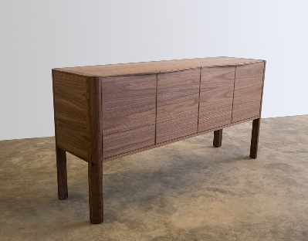
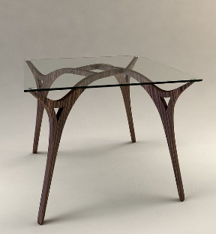
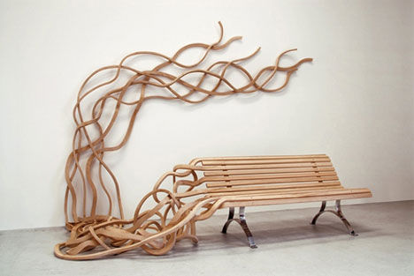
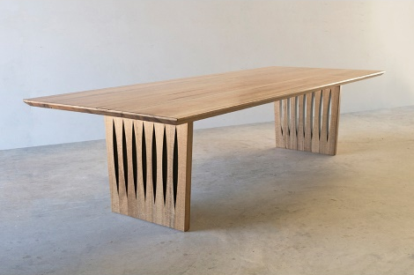
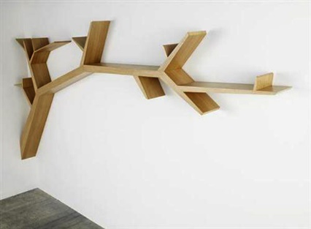
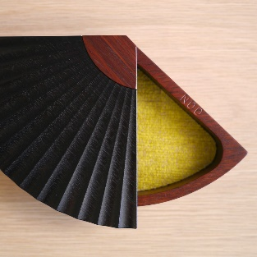
Contents
Design 3
Development of Major Project Name and Identity 3
Idea Generation 8
Sketching 11
Prototyping 15
Modeling and Testing 16
Production and Working Drawings 18

Design

Development of Major Project Name and Identity

What was the original name I thought of for my major project?

________________________________________________________

Possible names for my Major Project…

1._______________________________________________________________________________________
2._______________________________________________________________________________________
3._______________________________________________________________________________________
4._______________________________________________________________________________________
5._______________________________________________________________________________________

Example: 1. Recycled rocking chair

Place a picture in the square provided of a logo design for either your major project or a company name…

1.___________________________
____________________________
____________________________
____________________________
____________________________
____________________________
____________________________
____________________________
____________________________
____________________________
____________________________
____________________________

In the spaces provided include a logo design and then talk about why you have chosen this style or name for your major project or company name…

Place a picture in the square provided of a logo design for either your major project or a company name…

2.___________________________
____________________________
____________________________
____________________________
____________________________
____________________________
____________________________
____________________________
____________________________
____________________________
____________________________
____________________________

In the spaces provided include a logo design and then talk about why you have chosen this style or name for your major project or company name…

Place a picture in the square provided of a logo design for either your major project or a company name…

3.___________________________
____________________________
____________________________
____________________________
____________________________
____________________________
____________________________
____________________________
____________________________
____________________________
____________________________
____________________________

In the spaces provided include a logo design and then talk about why you have chosen this style or name for your major project or company name…

Place a picture in the square provided of a logo design for either your major project or a company name…

4.___________________________
____________________________
____________________________
____________________________
____________________________
____________________________
____________________________
____________________________
____________________________
____________________________
____________________________
____________________________

In the spaces provided include a logo design and then talk about why you have chosen this style or name for your major project or company name…

Idea Generation

Create a mind map in the box of the different things associated with your project, like parts of your project or machines or tools related to your project that you need to learn about. It could be a material you need to use or construction process or specific joint you want to explore and test.

Create a mind map in the box of the different things associated with your project, like parts of your project or machines or tools related to your project that you need to learn about. It could be a material you need to use or construction process or specific joint you want to explore and test.

Create a mind map in the box of the different things associated with your project, like parts of your project or machines or tools related to your project that you need to learn about. It could be a material you need to use or construction process or specific joint you want to explore and test.

Sketching

Sketch some drawings of your project in the boxes provided. You can sketch parts of it or some designs you might want to add to certain parts of your project. This section is for you to play around with different design ideas to make your project more complex.

Make sure you include annotations with your drawings.
In the boxes provided on the next few pages create some sketches including some rough dimensions for your project.

Make sure you include annotations with your drawings.
In the boxes provided on the next few pages create some sketches including some rough dimensions for your project.

Make sure you include annotations with your drawings.
In the boxes provided on the next few pages create some sketches including some rough dimensions for your project.

Make sure you include annotations with your drawings.

Prototyping

This section is the fun part. Use foam, timber, Perspex, plastic, cardboard, paper or any type of material to model a small scale prototype of your project.
In the boxes provide pictures of this model when you have finished making it.

Remember to include annotations
You can use this model for display when you present your HSC major project so make sure you keep it in a safe place and don’t lose it.

Modeling and Testing

This section is also the fun part. Use scrap timber to model and test different types of joints that you will sue in your major project. In the boxes provide pictures of your models when you have finished making it. A second page has been allocated for modeling and testing.

Remember to include annotations
You can use these models for display when you present your HSC major project so make sure you keep them in a safe place and don’t lose it.
This section is also the fun part. Use scrap timber to model and test different types of joints that you will sue in your major project. In the boxes provide pictures of your models when you have finished making it.

Remember to include annotations
You can use these models for display when you present your HSC major project so make sure you keep them in a safe place and don’t lose it.

Production and Working Drawings

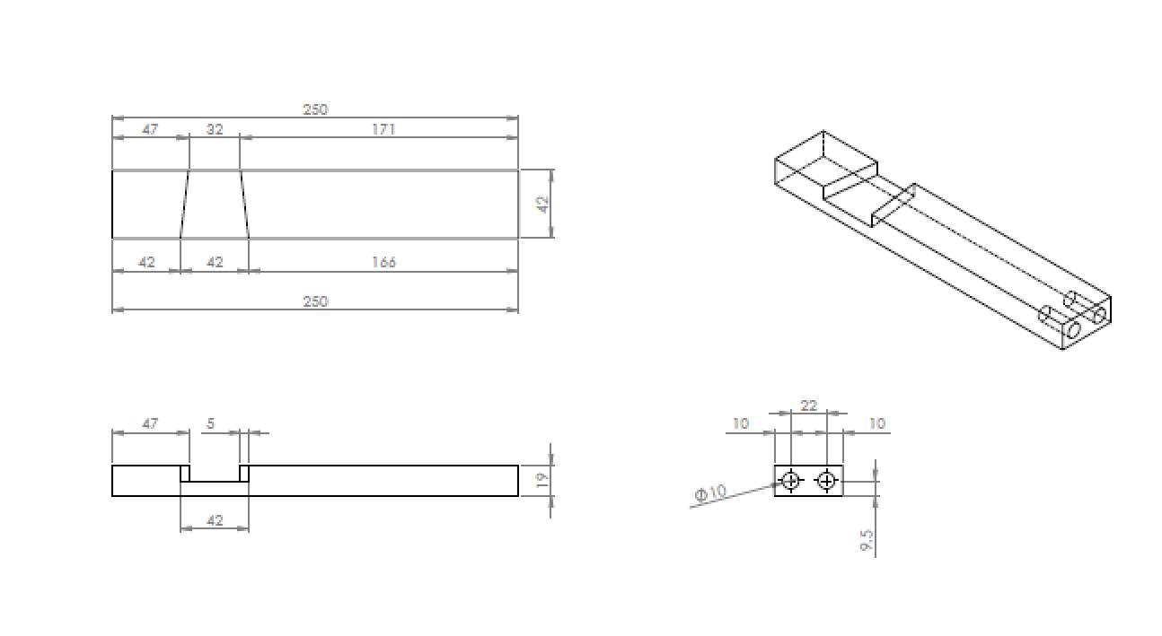
This section is for Solidworks models to be created and working drawings to be printed off. Your teacher will help you with this section and we will work on this as soon as your developing ideas section is complete. Here are a few example of what this could look like.

