THOMAS
HASSALL
ANGLICAN
COLLEGE

Year 11 Industrial Technology Portfolio Workbook
Research section

Student Name: ___________________________
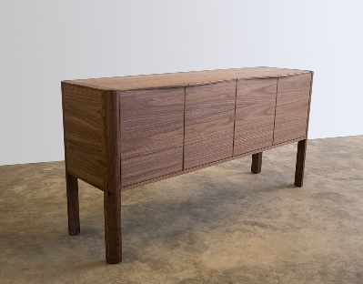
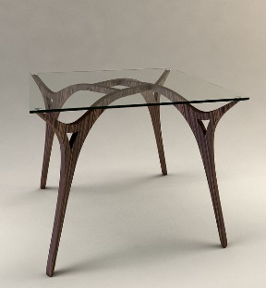
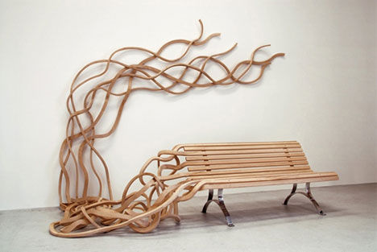
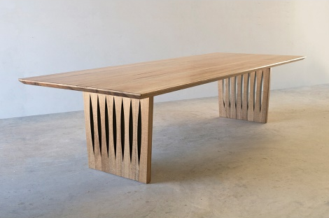
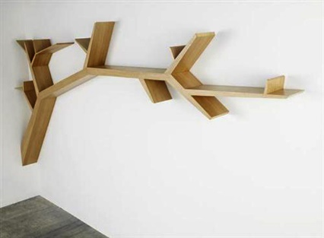
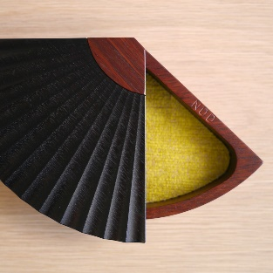
Contents
Design 3
Research 3
What types of furniture am I interested in to motivate my major project? 3
Ergonomics 6
Types of timbers you can use 8
Types of timber joints specific to your project 9
Pieces of furniture that have inspired you to create your master piece 15
Visiting furniture shops for furniture related to your major project 17
Conclusion – ongoing evaluation 18

Design

Research

What types of furniture am I interested in to motivate my major project?

1._______________________________________________________2._______________________________________________________3._______________________________________________________4._______________________________________________________5._______________________________________________________

Example: 1. Rocking chair…

Place a picture in the square provided of each of the types of furniture you are interested in making…

1.___________________________
____________________________
____________________________
____________________________
____________________________
____________________________
____________________________
____________________________
____________________________
____________________________
____________________________
____________________________

In the spaces provided include a picture and then talk about the piece of furniture, good points, bad points, things that might be difficult to make…

2.___________________________
____________________________
____________________________
____________________________
____________________________
____________________________
____________________________
____________________________
____________________________
____________________________
____________________________
____________________________

In the spaces provided include a picture and then talk about the piece of furniture, good points, bad points, things that might be difficult to make…

3.___________________________
____________________________
____________________________
____________________________
____________________________
____________________________
____________________________
____________________________
____________________________
____________________________
____________________________
____________________________

In the spaces provided include a picture and then talk about the piece of furniture, good points, bad points, things that might be difficult to make…

4.___________________________
____________________________
____________________________
____________________________
____________________________
____________________________
____________________________
____________________________
____________________________
____________________________
____________________________
____________________________

In the spaces provided include a picture and then talk about the piece of furniture, good points, bad points, things that might be difficult to make…

5.___________________________
____________________________
____________________________
____________________________
____________________________
____________________________
____________________________
____________________________
____________________________
____________________________
____________________________
____________________________

In the spaces provided include a picture and then talk about the piece of furniture, good points, bad points, things that might be difficult to make…

Ergonomics

Ergonomic design is important and can be the difference between a well-designed piece of furniture and one that is useless. We want to determine how the piece of furniture will fit the average human body and how people use it.

Write down the parts of the human body that will be affected with your major project?

1._______________________________________________________2._______________________________________________________3._______________________________________________________4._______________________________________________________5._______________________________________________________
Example: 1. Peoples legs will be affected when using my coffee table as they will possibly rest their legs on it. Therefore my coffee table will need to be a specific height comfortable enough for stretched out legs.
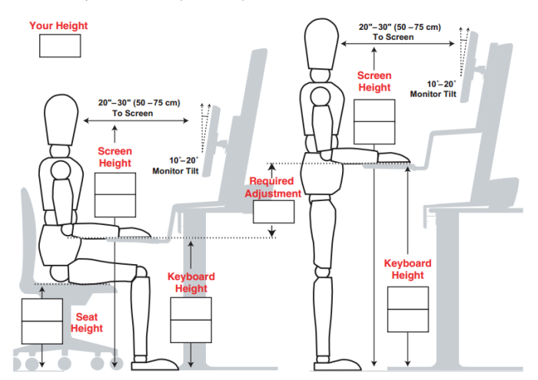
Figure 1: Ergonomic picture accessed from sparkproductivity.com

This picture is an example of what you could include…

These boxes are provided for drawing diagrams of the human body and measurements that are specifically related to your major project (stick figures are fine).

Remember to include annotations and measurements in all of your sketches/drawings.

Types of timbers you can use

Choosing a timber type can be difficult, especially finding the right place to buy at the right price. Below are some links for you to look at and to check out what is available at what size.
Pendle Hill
harpertimber.com.au
Marrickville
Mulgrave
Minto
Prestons
St. Marys
matthewtimbers.com.au
anagote.com
acaciatimbers.com.au
brittontimbers.com.au
trendtimbers.com.au

Types of timber joints specific to your project

Choosing a timber joint can be difficult, you need to find the right type of joint for the type of furniture you choose. For the top of a table you would not just butt joint it together you would biscuit joint or dowel joint it together for strength. A mortise and tenon joint would be best for a rail to leg join for a chair as opposed to a dowel joint.

For example…

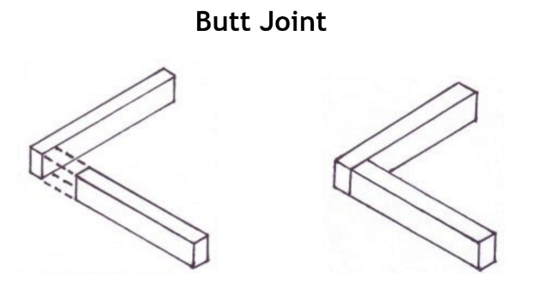
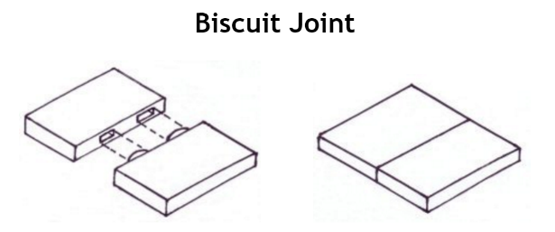

Figure 2: Butt Joint accessed from woodworkbasics.com
Figure 3: Biscuit Join accessed from woodworkbasics.com

Justification:__________________________________________________________________________________________________________________________________________________________________________________________________________________________________________________________________________________________________________________________________________________________________________________________________________________________________________________________________________________________________

Example: Figure 2 doesn’t have enough strength for a table top, however figure 3 is strong enough for a table top allowing pressure to be placed on from human arms, elbows and eating utensils. If this same pressure was placed on figure 2 it could easily be damaged and be dangerous for everyday use.

For example…
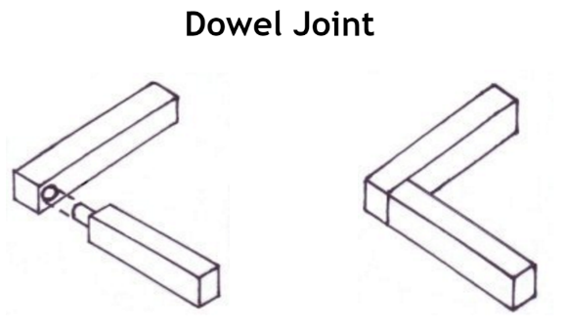
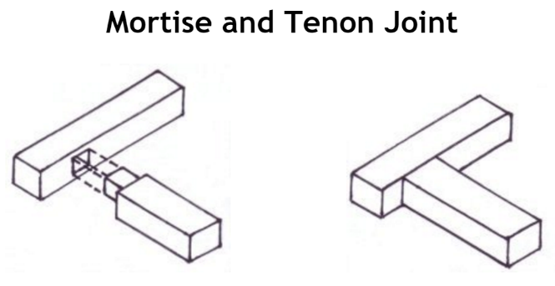
Figure 5: Mortise and tenon joint accessed from woodworking basics.com
Figure 4: Dowel joint accessed from woodworking basics.com

Example: Figure 4 doesn’t have enough strength for a chair leg, however figure 5 is strong enough for a chair leg allowing pressure to be placed on from the human body in a seating position. If this same pressure was placed on figure 4 it could easily be damaged and be dangerous for everyday use.

For this section select the types of timber joints you would like to use for your project and talk about the advantages and disadvantages of each joint. Draw or copy a picture of the joint in the box provided and talk about this joint for your project, you could mention strength, size, durability, difficulty, aesthetical features and so on…

1.___________________________
____________________________
____________________________
____________________________
____________________________
____________________________
____________________________
____________________________
____________________________
____________________________
____________________________
____________________________

When you have completed this section you will need to state the reasons why you are choosing your joints for different parts of your project and why you have chosen them, justification…

Joint I Justification: ______________________________________________________________________________________________________________________________________________________________________________________________________________________________________________________________________________________________________________________________________________________________________________________________________________________________________________________________________________________________________________________________________________________________________________________________

Example: the reason I have chosen a mortise and tenon joint for my stairs is because it is the strongest joint you can use, however in using this joint I realize that it will take more time. In saying this I need to allocate more time for accuracy to get the joints perfectly correct for maximum durability and strength.

2.___________________________
____________________________
____________________________
____________________________
____________________________
____________________________
____________________________
____________________________
____________________________
____________________________
____________________________
____________________________

Joint 2 Justification: ______________________________________________________________________________________________________________________________________________________________________________________________________________________________________________________________________________________________________________________________________________________________________________________________________________________________________________________________________________________________________________________________________________________________________________________________

3.___________________________
____________________________
____________________________
____________________________
____________________________
____________________________
____________________________
____________________________
____________________________
____________________________
____________________________
____________________________

Joint 3 Justification: ______________________________________________________________________________________________________________________________________________________________________________________________________________________________________________________________________________________________________________________________________________________________________________________________________________________________________________________________________________________________________________________________________________________________________________________________

4.___________________________
____________________________
____________________________
____________________________
____________________________
____________________________
____________________________
____________________________
____________________________
____________________________
____________________________
____________________________

Joint 4 Justification: ______________________________________________________________________________________________________________________________________________________________________________________________________________________________________________________________________________________________________________________________________________________________________________________________________________________________________________________________________________________________________________________________________________________________________________________________

5.___________________________
____________________________
____________________________
____________________________
____________________________
____________________________
____________________________
____________________________
____________________________
____________________________
____________________________
____________________________

Joint 5 Justification: ______________________________________________________________________________________________________________________________________________________________________________________________________________________________________________________________________________________________________________________________________________________________________________________________________________________________________________________________________________________________________________________________________________________________________________________________

Example: the reason I have chosen a mortise and tenon joint for my stairs is because it is the strongest joint you can use, however in using this joint I realize that it will take more time. In saying this I need to allocate more time for accuracy to get the joints perfectly correct for maximum durability and strength.

Pieces of furniture that have inspired you to create your master piece

Place a picture in the square provided of each of the types of furniture that have inspired you to make certain decisions…

1.___________________________
____________________________
____________________________
____________________________
____________________________
____________________________
____________________________
____________________________
____________________________
____________________________
____________________________
____________________________

In the spaces provided include a picture and then talk about the piece of furniture that has inspired you and mention the specific part that you may want to include or whether it has just inspired your creation…

2.___________________________
____________________________
____________________________
____________________________
____________________________
____________________________
____________________________
____________________________
____________________________
____________________________
____________________________
____________________________

In the spaces provided include a picture and then talk about the piece of furniture that has inspired you and mention the specific part that you may want to include or whether it has just inspired your creation…

3.___________________________
____________________________
____________________________
____________________________
____________________________
____________________________
____________________________
____________________________
____________________________
____________________________
____________________________
____________________________

In the spaces provided include a picture and then talk about the piece of furniture that has inspired you and mention the specific part that you may want to include or whether it has just inspired your creation…

4.___________________________
____________________________
____________________________
____________________________
____________________________
____________________________
____________________________
____________________________
____________________________
____________________________
____________________________
____________________________

In the spaces provided include a picture and then talk about the piece of furniture that has inspired you and mention the specific part that you may want to include or whether it has just inspired your creation…

Visiting furniture shops for furniture related to your major project

Furniture shop visited: _______________________________________________________________

Product I looked at: _________________________________________________________________

Description of product: ______________________________________________________________
__________________________________________________________________________________________________________________________________________________________________________________________________________________________________________________________________________________________________________________________________________________________________________________________________________________________

Picture of product I looked at __________________________________________ __________________________________________ __________________________________________ __________________________________________ __________________________________________ __________________________________________ __________________________________________ __________________________________________ __________________________________________ __________________________________________ __________________________________________ __________________________________________ __________________________________________ __________________________________________

Place a picture of the product that you looked at and in the space provided put some key features that you like or that have inspired you for your project.

Furniture shop visited: _______________________________________________________________

Product I looked at: _________________________________________________________________

Description of product: ______________________________________________________________
__________________________________________________________________________________________________________________________________________________________________________________________________________________________________________________________________________________________________________________________________________________________________________________________________________________________

Picture of product I looked at __________________________________________ __________________________________________ __________________________________________ __________________________________________ __________________________________________ __________________________________________ __________________________________________ __________________________________________ __________________________________________ __________________________________________ __________________________________________ __________________________________________ __________________________________________ __________________________________________

Place a picture of the product that you looked at and in the space provided put some key features that you like or that have inspired you for your project.

Furniture shop visited: _______________________________________________________________

Product I looked at: _________________________________________________________________

Description of product: ______________________________________________________________
__________________________________________________________________________________________________________________________________________________________________________________________________________________________________________________________________________________________________________________________________________________________________________________________________________________________

Picture of product I looked at __________________________________________ __________________________________________ __________________________________________ __________________________________________ __________________________________________ __________________________________________ __________________________________________ __________________________________________ __________________________________________ __________________________________________ __________________________________________ __________________________________________ __________________________________________ __________________________________________

Place a picture of the product that you looked at and in the space provided put some key features that you like or that have inspired you for your project.

Conclusion – ongoing evaluation

________________________________________________________________________________________________________________________________________________________________________________________________________________________________________________________________________________________________________________________________________________________________________________________________________

Example: in conclusion to my research my intention to make a coffee table has enabled me to add features to my design that were not there before. The research has guided me in the process of choosing my timber for my major project…

