Advice of Year 10 Assessment Task One

Subject/Course: Industrial Technology - Timber

“Emerging Technologies - CAM”
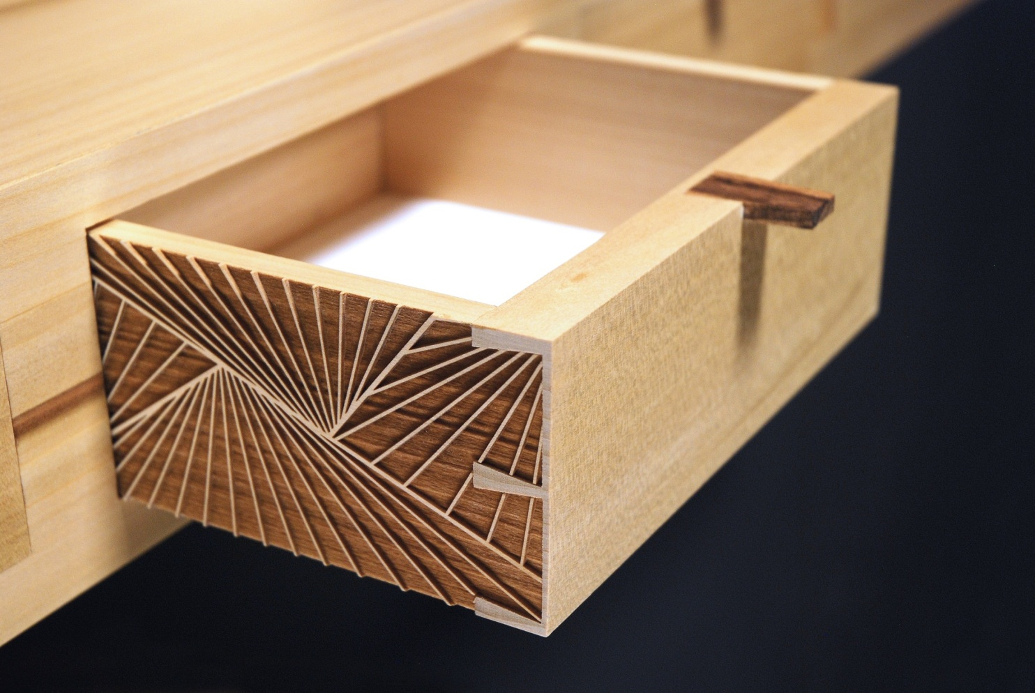

The Assessment Task is required to be completed at home. Some class time will be allocated to the completing of the task. Submission is required on Thursday March 28th by 2:40pm.

The teacher will advise you of the periods available where you can work on your assessment task.

Weighting of Assessment (%): 20%

Total Marks: Structured 70, Core 85, Extension 100.

Outcomes being assessed:

5.1.1 | identifies, assesses and manages the risks and OHS issues associated with the use of a range of materials, hand tools, machine tools and processes
5.1.2 | applies OHS practices to hand tools, machine tools, equipment and processes
5.2.1 | applies design principles in the modification, development and production of projects
5.4.1 | selects, applies and interprets a range of suitable communication techniques in the development, planning, production and presentation of ideas and projects
5.5.1 | applies and transfers acquired knowledge and skills to subsequent learning experiences in a variety of contexts and projects
5.6.1 | evaluates products in terms of functional, economic, aesthetic and environmental qualities and quality of construction
5.7.1 | describes, analyses and uses a range of current, new and emerging technologies and their various applications
5.7.2 | describes, analyses and evaluates the impact of technology on society, the environment and cultural issues locally and globally
 | Elementary CAD Applications

Core Response

Standard Submission

Maximum 85%
Extension Response

Maximum Submission

Maximum 100%
Structured Response

Minimum Submission

Maximum 70%

Optional Response

Scenario
You are required to design a workshop that consists of Computer Aided Manufacturing (CAM) hardware. You are to establish the Workshop for the first time which should include:
- Salary for 3 staff
- Industrial unit rent
- CAM Machinery
- Computer Hardware
- Workshop equipment. ie, Dust Filtration, Saws, First Aid Kit, PPE, etc.

The CAM workshop is to produce Timber furniture.

Report - Structured

You are required to write a report on the provided scenario. The report must include the following sections:
- Title Page
- Contents Page
- Introduction – Provide a detailed description of the needs of your chosen workshop.
- Gantt Chart – Create a Gantt chart which will illustrate your planned progress and actual progress through this Task.
- Hardware Specification and Costings
  - What are the requirements of the Location?
  - What tooling and machinery are required?
  - What are the computing requirements?
  - What are the training requirements for staff?
- Ergonomics – Discuss the ergonomic principles which apply to your chosen profession. Include factors such as:
  - Room size
  - Lighting
  - Ventilation
- Comparison - Compare and contrast Industrial Processes with those undertaken in the classroom
- Conclusion – A brief evaluation of your design.
- Bibliography

Report - Core
- Hardware Specification and Costings
- Are there WHS considerations?
- Ergonomics:
- Work space requirements including zoning around each machine
- Conclusion – A comprehensive evaluation of your design.

Report - Extension
- Hardware Specification and Costings
- An itemised cost list of the system. Include the projected life expectancy of each component.
- Ergonomics:
  - Include a 2D or 3D computer aided drawing (CAD). (See Page 5 for instruction)
- Conclusion – An extensive evaluation of your design.

Extension Response: CAD Model

You are required to create a 2D or 3D engineering drawing of the CAM Workshop and any other offices or workspaces., and computer system.
You may use any CAD package currently installed on the college network, but it is recommended that you complete the assignment using SketchUp.

The CAD model should meet the following criteria:

Drawn to 1:1 scale

Each hardware component listed in Part. Particular attention should be given to the size of the work space, along with the positioning and size of the equipment and lighting.

Please see marking criteria for further detail.

Submission:
This part of the assessment task will need to be saved within your home drive.
- Create a folder labelled “AT1 – Your Name”
- Within that folder include your finished report in PDF format and SketchUp File if included.

